

**NEWS TRACKER APPLICATION**

USING CLOUD

*A Project report submitted in partial fulfilment of 7th semester in degree Of*

BACHELOR OF ENGINEERING

IN

**COMPUTER SCIENCE AND ENGINEERING**

*Submitted By*

**Team ID:** PNT2022TMID33422

**Team Members:**

**Team Leader** Sathiya Sri K 922519104143

**Team Member 01** Sindhu T 922519104148

**Team Member 02** Venimalathy A 922519104176

**Team Member 03** Suruthi R 922519104168



**DEPARTMENT OF COMPUTER SCIENCE AND ENGINEERING**

**UNIVERSITY COLLEGE OF ENGINEERING, ARIYALUR**

ANNA UNIVERSITY: CHENNAI 600025

**NOV-2022**

**V.S.B ENGINEERING COLLEGE, KARUR**

**(Approved by AICTE & Affiliated by Anna University, Chennai)**



**BONAFIDE CERTIFICATE**

Certified that this project report “**NEWS TRACKER APPLICATION”** is the Bonafide record work done by **Ms SATHIYA SRI K**(**922519104029**), **Ms SINDHU T**(**922519104042**), **Ms VENIMALATHY A**(**922519104025)**,and **Ms SURUTHI R**(**922519104038**)for **IBM- NALAIYATHIRAN** in **VII** semester of **B.E.,** degree course **in Computer Science and Engineering** branch during the academic year of 2022 – 2023.



**ACKNOWLEDGEMENT**

First and foremost, we express my thanks to our parents for providing us a very nice environment for doing this mini project. We wish to express our sincere thanks to our founder and Chairman **Shri.V.S.BALSAMY** for his endeavour in educating us in this premier institution.

We wish to express our appreciation and gratefulness to our principal, **Dr.V.NIRMAL KANNAN** and vice principal **Mr.T.S.KIRUBASANKAR** for their encouragement and sincere guidance.

We are grateful to our head of the department **Mr.P.ANBUMANI** and our IBM Nalaiyathiran project coordinator **Mr.P.GUNASEKARAN** Department of Computer Science and Engineering for their valuable support.

We express our indebtedness to the supervisor of our IBM Nalaiyathiran project, **Mr.P.GUNASEKARAN** Assistant Professor, Department of Computer Science and Engineering, for guidance throughout the course of our project.

Our sincere thanks to all the teaching staff of V.S.B Engineering College and our friends for their help in the successful completion of this IBM Nalaiyathiran project work. Finally, we bow before God, the Almighty who always had a better plan for us. We give our praise and glory to Almighty God for successful completion of this IBM Nalaiyathiran.

**ABSTRACT**

A news application is a major intelligent data set that recounts a report. Think about it like you would some other piece of news coverage. It simply utilizes programming rather than words and pictures. As our lives are exceptionally bustling nowadays, we frequently feel we want in excess of 24 hours. a day to adapt up to all that we have in our timetable. Indeed, that is unrealistic yet diminishing the time by changing the traditional strategy for pursuing news can help. Simply let us know what market news you're keen on and get a fast look for the afternoon. Just read what you feel is applicable and save your time.Paper is one of the most well known and required resources of our regular routines. Also, in the present rushed world, perusing paper has become one of the conventional approaches to perusing the news. With the news being made consistently and handed-off through television, radio and web, the refreshed news is now old by the following morning. Furthermore, that is the reason paper and magazine distributors are battling to stay aware of the speed. Change is required and distributors should embrace versatility.

**TABLE OF FIGURES**

1. **INTRODUCTION** 
   1. Project Overview
   2. Purpose
2. **LITERATURE SURVEY** 
   1. Existing problem
   2. References
   3. Problem Statement Definition
3. **IDEATION & PROPOSED SOLUTION** 
   1. Empathy Map Canvas
   2. Ideation & Brainstorming
   3. Proposed Solution
   4. Problem Solution fit
4. **REQUIREMENT ANALYSIS** 
   1. Functional requirement
   2. Non-Functional requirements
5. **PROJECT DESIGN** 
   1. Data Flow Diagrams
   2. Solution & Technical Architecture
   3. User Stories
6. **PROJECT PLANNING & SCHEDULING** 
   1. Sprint Planning & Estimation
   2. Sprint Delivery Schedule
   3. Reports from JIRA
7. **CODING & SOLUTIONING** 
   1. Feature 1
   2. Feature 2
   3. Database Schema (if Applicable)
8. **TESTING** 
   1. Test Cases
   2. User Acceptance Testing
9. **RESULTS** 
   1. Performance Metrics
10. **ADVANTAGES & DISADVANTAGES**
11. **CONCLUSION**

**Source Code GitHub & Project Demo Link**

**NEWS TRACKER APPLICATION**

**1.INTRODUCTION**

The client wanted to create a solution to facilitate work for media professionals through a location-based assignment management tool. The main challenge was to create a system on which journalists and other staff remained connected, and could locate or contact each other swiftly to relay stories faster.We built NewsTracker to collect a variety of sources of misinformation on Facebook and aggregate the stories published so that we could have a clearer sense of the different types of misinformation out there. We wanted to know how frequently it was published and what strategies and narratives were employed to engage audiences on Facebook.

* 1. **PROJECT OVERVIEW**

The project's goal is to create an application that will show news items and videos that have been reviewed and approved at the back end. The user can search through many categories of news articles and videos. Users will be able to view news details, photographs, and video using the app. Any news story or video can be bookmarked by users for later use. At the backend of the programme, there will be three different types of users. The admin manager will have complete access to all backend capabilities, including user and content management. The only other users who will have limited access to backend functions are reporters and editors. While reporters will be responsible for writing news articles and producing news videos, editors will be in charge of approving and publishing the reporters' articles and films**.**

* 1. **PURPOSE**
* A news application grants you to assemble data in regards to the clients' way of behaving and interests and further develop it to sort out happy relying upon the singular's necessities. Assuming that you follow a few major distributors, you can see that their news applications are only a versatile rendition of their destinations. Online News Destinations assume a huge part in teaching and illuminating Mass with the most up to date refreshes, current happenings all over the planet. Individuals don't have undeniably additional opportunity to peruse the Printed paper with the previous happening so they generally follow online interfaces or Electronic Media for getting the most recent News.

**2.LITERATURE SURVEY**

**2.1 EXISTING PROBLEM**

We often feel we need more than 24 hrs. a day to cope up with everything we have in our schedule. Well, that's not possible but reducing the time by changing the conventional method of reading news can help.

**2.2 REFERENCES**

[1] Gnimpieba, Z. D. R., Nait-Sidi-Moh, A., Durand, D., & Fortin, J. (2015). Using cloud computing technologies for a collaborative supply chain: Application to tracking of pallets and containers. Procedia Computer Science, 56, 550-557

[2] Zayene, O., Hennebert, J., Touj, S. M., Ingold, R., & Amara, N. E. B. (2015, August). A dataset for Arabic text detection, tracking and recognition in news videos-AcTiV. In 2015 13th International Conference on Document Analysis and Recognition (ICDAR) (pp. 996-1000)IEEE

[3] Allan, J., Carbonell, J. G., Doddington, G., Yamron, J., & Yang, Y. (1998).

[4] Berendt, B., & Subasic, I. (2009, September). STORIES in time: a graph-based interface for news tracking and discovery. In 2009 IEEE/WIC/ACM International Joint Conference on Web Intelligence and Intelligent Agent Technology (Vol. 3, pp. 531-534). IEEE.

[5] Aksoy, C., Can, F., & Kocberber, S. (2012). Novelty detection for topic tracking. Journal of the american society for information science and technology, 63(4), 777-795

**2.3 PROBLEM STATEMENT DEFINITION**

1.The user needs a way to organize the news on a daily basis so that he can cope up with daily events in his tight schedule.

2.The user wants to read news only about particular topics so that he can be informed about his interest.

3.The user wants to get informed from only certified news outlets.

4.The user needs a way to search about the news on topics he wants to.

5.The user wants to know the news about his surrounding using GPS location

**3.IDEATION & PROPOSED SOLUTION**

**3.1 EMPATHY MAP CANVAS**

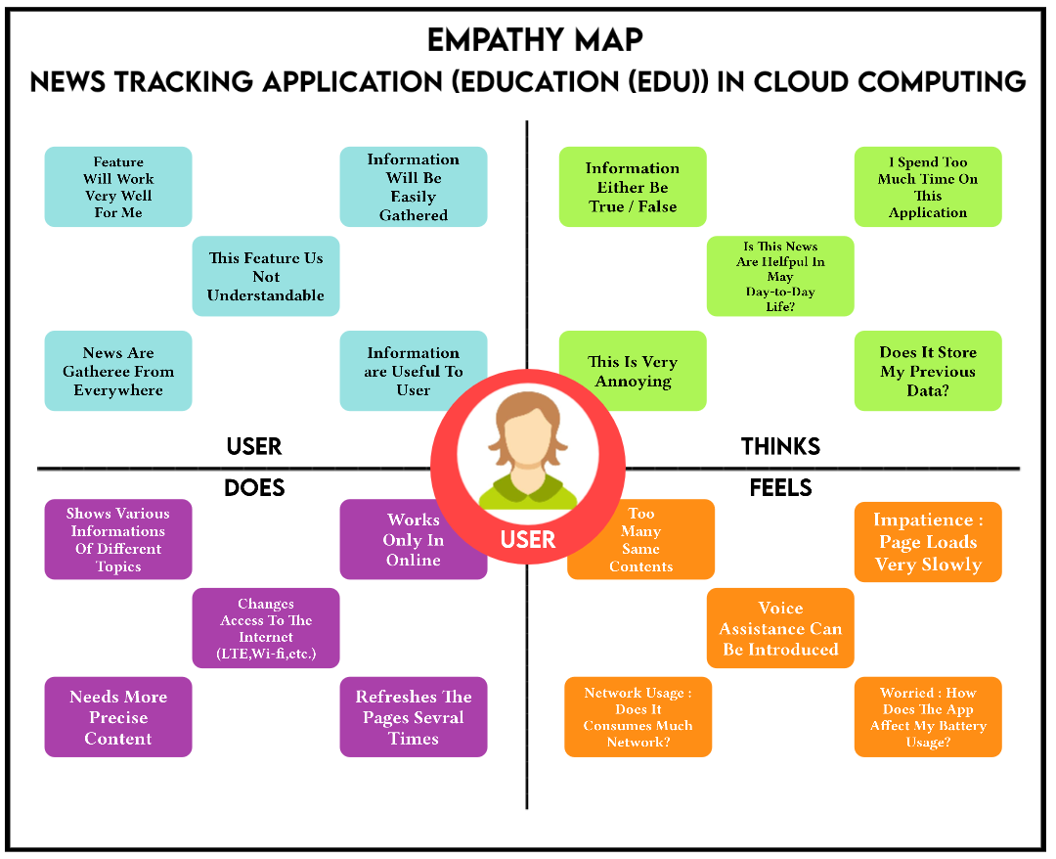

**3.2 IDEATION & BRAINSTORMING**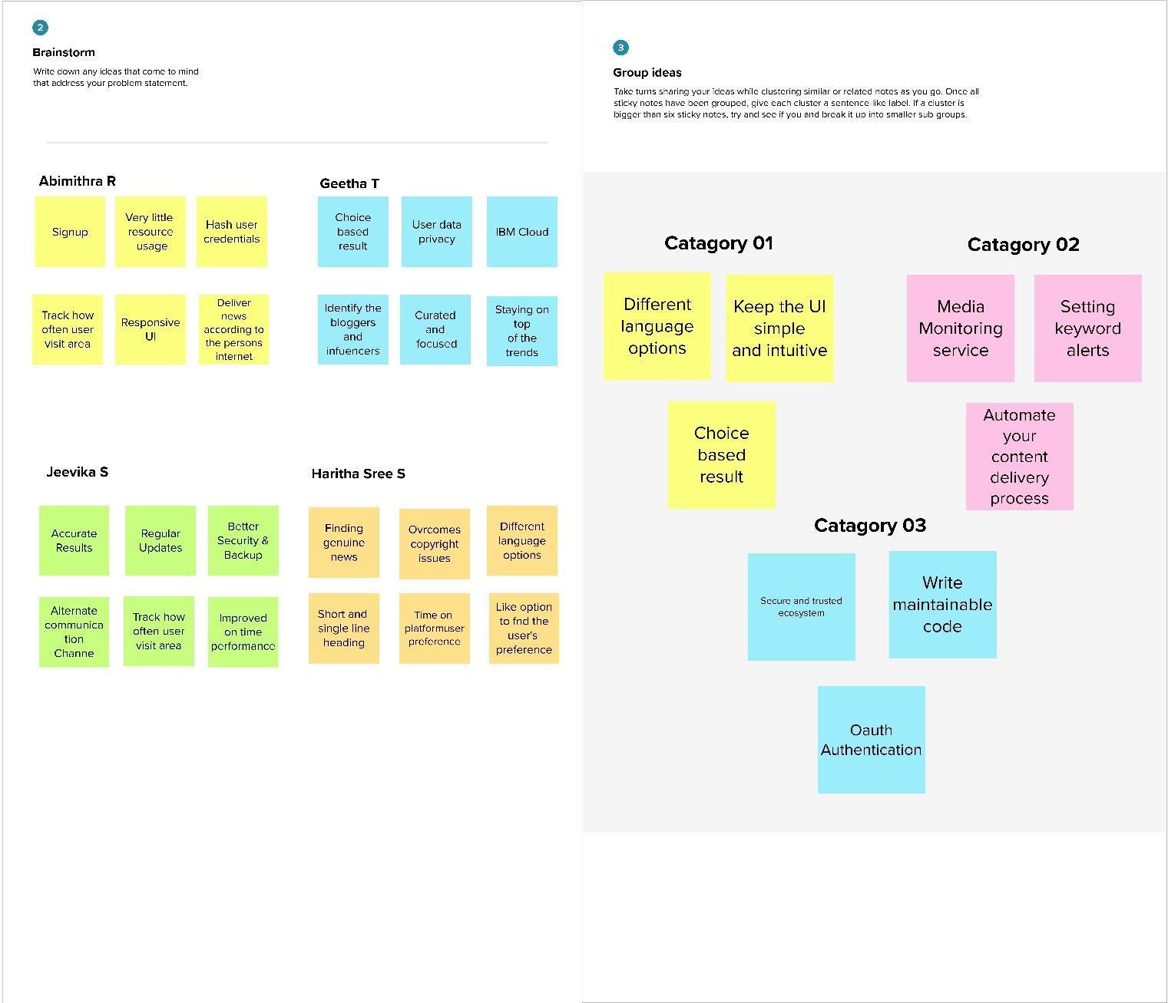

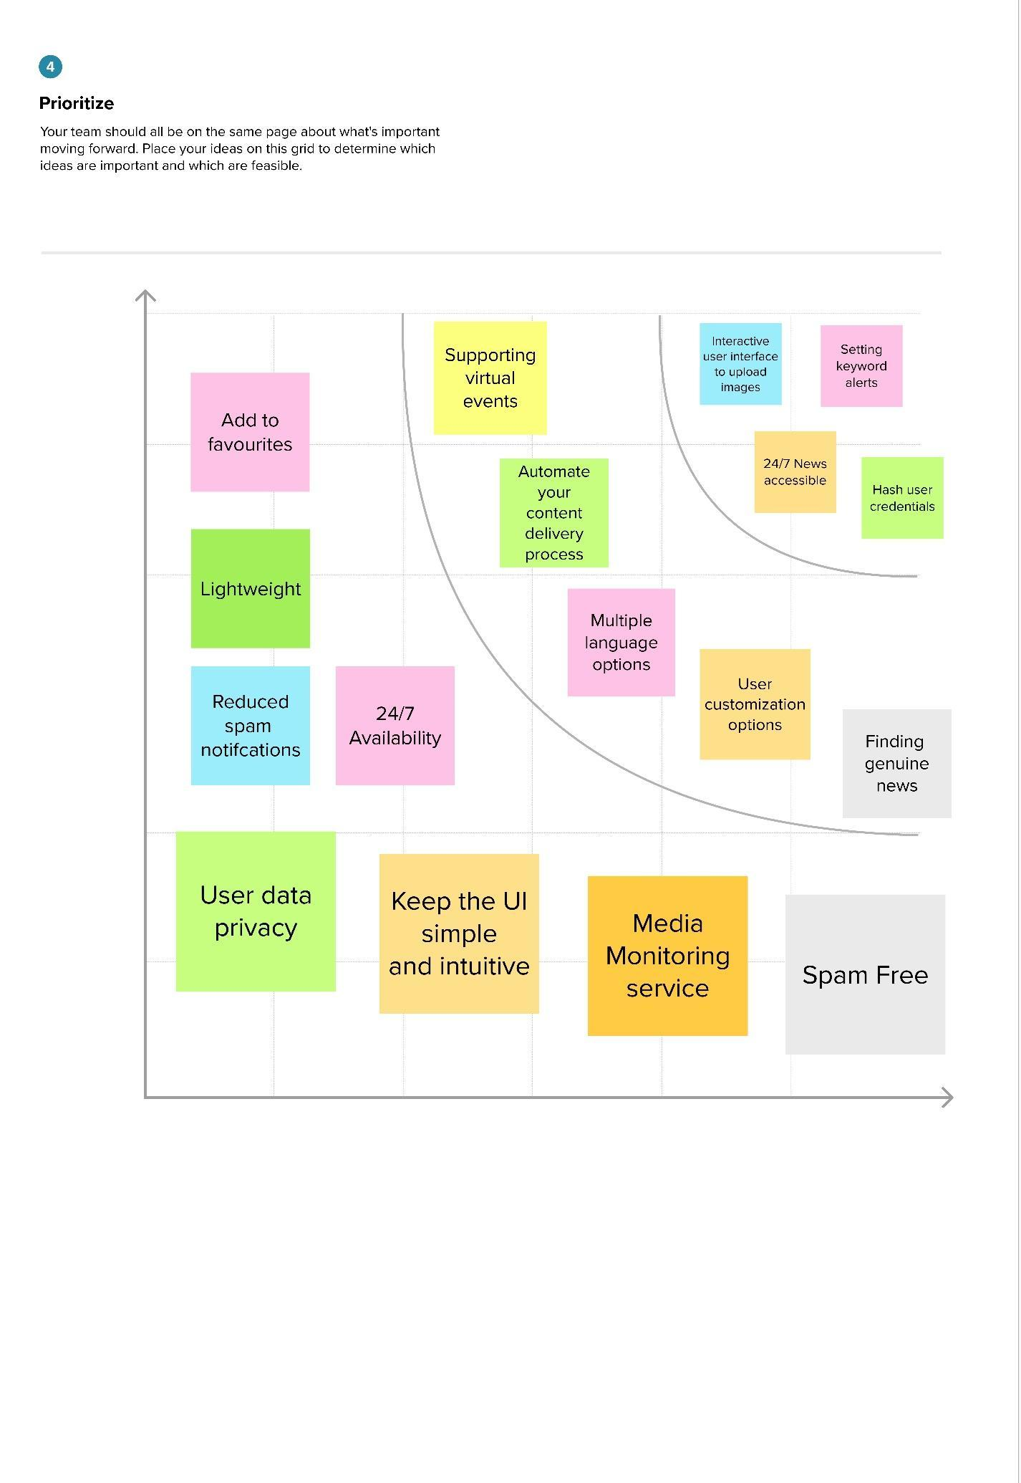

**3.3 PROPOSED SOLUTION**

| **S. No.** | **Parameter** | **Description** |
| --- | --- | --- |
| 1. | **Problem Statement (Problem to be solved)** | User needs to read in such a way that they don’t have to worry about ever buying physical newspapers or carrying with him everywhere. |
| 2. | **Idea / Solution description** | An application can be created where we can find, read news anywhere and at any time and it should be handy, easy to carry, less space, and easy to use. |
| 3. | **Novelty / Uniqueness** | A unique application specially made only to know information about news which is unique to the newspaper. The application can be designed in such a way that can attract kids too so that they can also learn and gain knowledge by reading news. |
| 4. | **Social Impact / Customer Satisfaction** | Customer satisfaction can be fulfilled by this application because it is user friendly, easily carryable, handy, etc. |
| 5. | **Business Model (Revenue Model)** | 1. Users are able to install the application from the play store at a free of cost so that the number of users will rapidly increase.  2.Application can have Advertisement feature. In such cases, the owner gets revenue from those advertisement sponsored companies. (More No. of Advertisement might get an irritation to the users)  3.An Advertisement-Free feature can be enabled for the users who can read or view news without any popup advertisements. |
| 6. | **Scalability of the Solution** | As it was an application-based project, a correct and neat application with no bugs and errors should be made so that the user might like our application and some might suggest and share to their surroundings, resulting in an increase of downloads and popularity in social medias. |

**3.4 PROBLEM SOLUTION FIT**

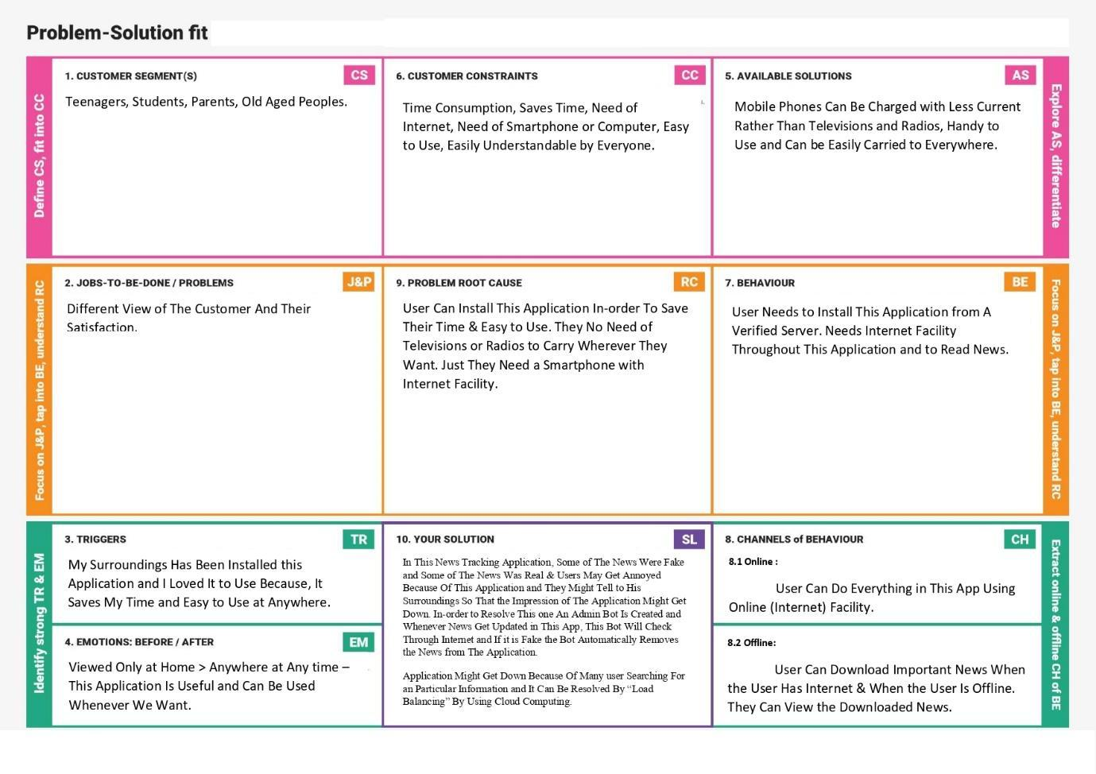

**4.REQUIREMENT ANALYSIS**

**4.1 FUNCTIONAL REQUIREMENTS**

Following are the functional requirements of the proposed solution.

| **FR No.** | **Functional**  **Requirement (Epic)** | **Sub Requirement**  **(Story / Sub-Task)** |
| --- | --- | --- |
| FR-1 | **User Registration** | 01. Registration through Form  02. Registration through Gmail  03. Registration through LinkedIn  04. Registration through Mobile Number  05. Registration through Facebook |
| FR-2 | **User Confirmation** | 01. Confirmation via Email  02. Confirmation via OTP |
| FR-3 | **Searching** | 01. Search the news based on the user interest  02. Showing the trending news on search  03. Showing the Category- wise news  04. User can save the news needed and study later  05. Searching Option Should Include Voice Assist |
| FR-4 | **Real time News** | Auto update news because it fetches news from API |
| FR-5 | **Location based** | 01. User can view the news based on their location  02. User can also change his location.  03. The Application Should recommend According to the place He / She is located |

**4.2 NON – FUNCTIONAL REQUIREMENTS**

Following are the non-functional requirements of the proposed solution.

| **FR No.** | **Non-Functional**  **Requirement** | **Description** |
| --- | --- | --- |
| NFR-1 | **Usability** | 01. The application should have a search bar for searching news based on keywords what the user needs to search for it  02. The Application Should Recommend his title when he / she is typing some of the letters of the title |
| NFR-2 | **Security** | The Login details of the user will be Secured by the policy of the application |
| NFR-3 | **Reliability** | 01. The application should provide appropriate and verified news.  02. The Application Should Not Provide Any Fake or Wrong News to the users |
| NFR-4 | **Performance** | 01. To keep users In-App for longer duration by showing related articles.  02. To show users the most relevant story first  03.The Application should not irritate the user |
| NFR-5 | **Availability** | The Application is available at Apple Store, Play Store, official Websites |
| NFR-6 | **Scalability** | 01. Gaining more users by encouraging social sharing.  02. Making advertisements and telecasting on social media platforms such as WhatsApp, Facebook, Twitter, Instagram etc. |

**5.PROJECT DESIGN**

**5.1 DATA FLOW DIAGRAM**

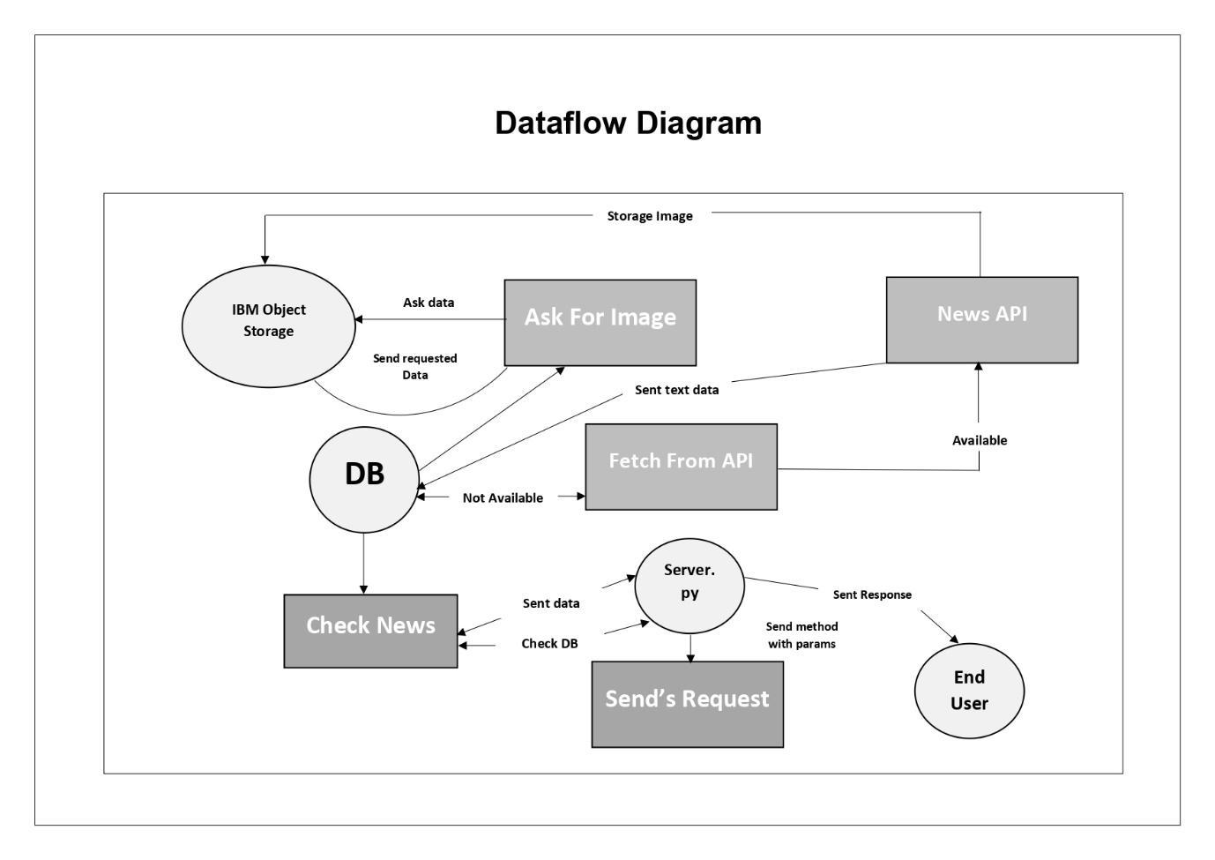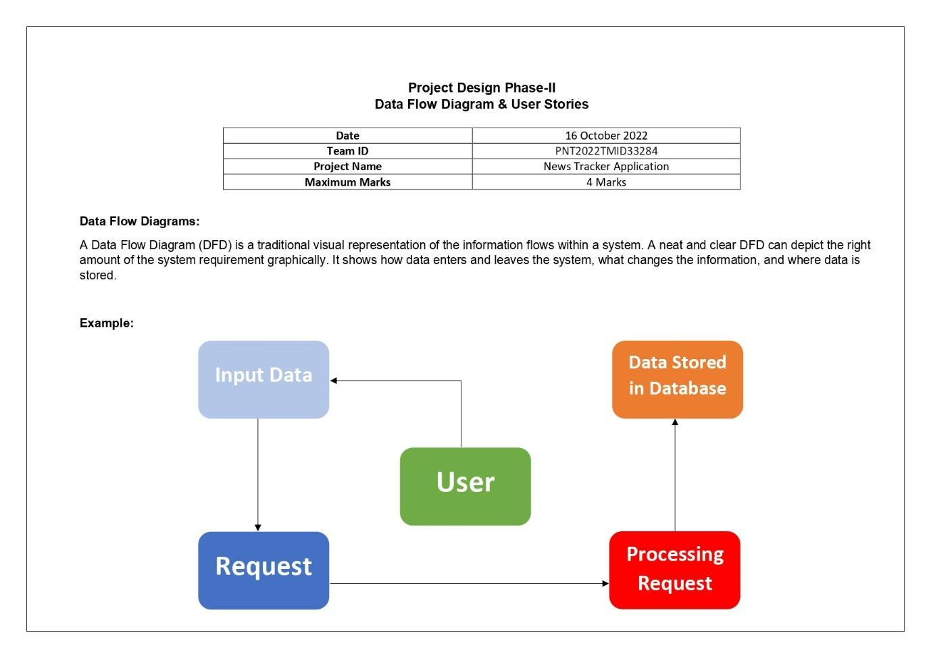

**5.2 SOLUTION & TECHNICAL ARCHITECTURE**

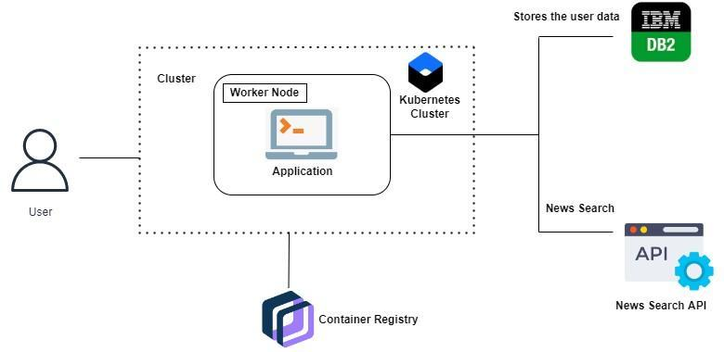

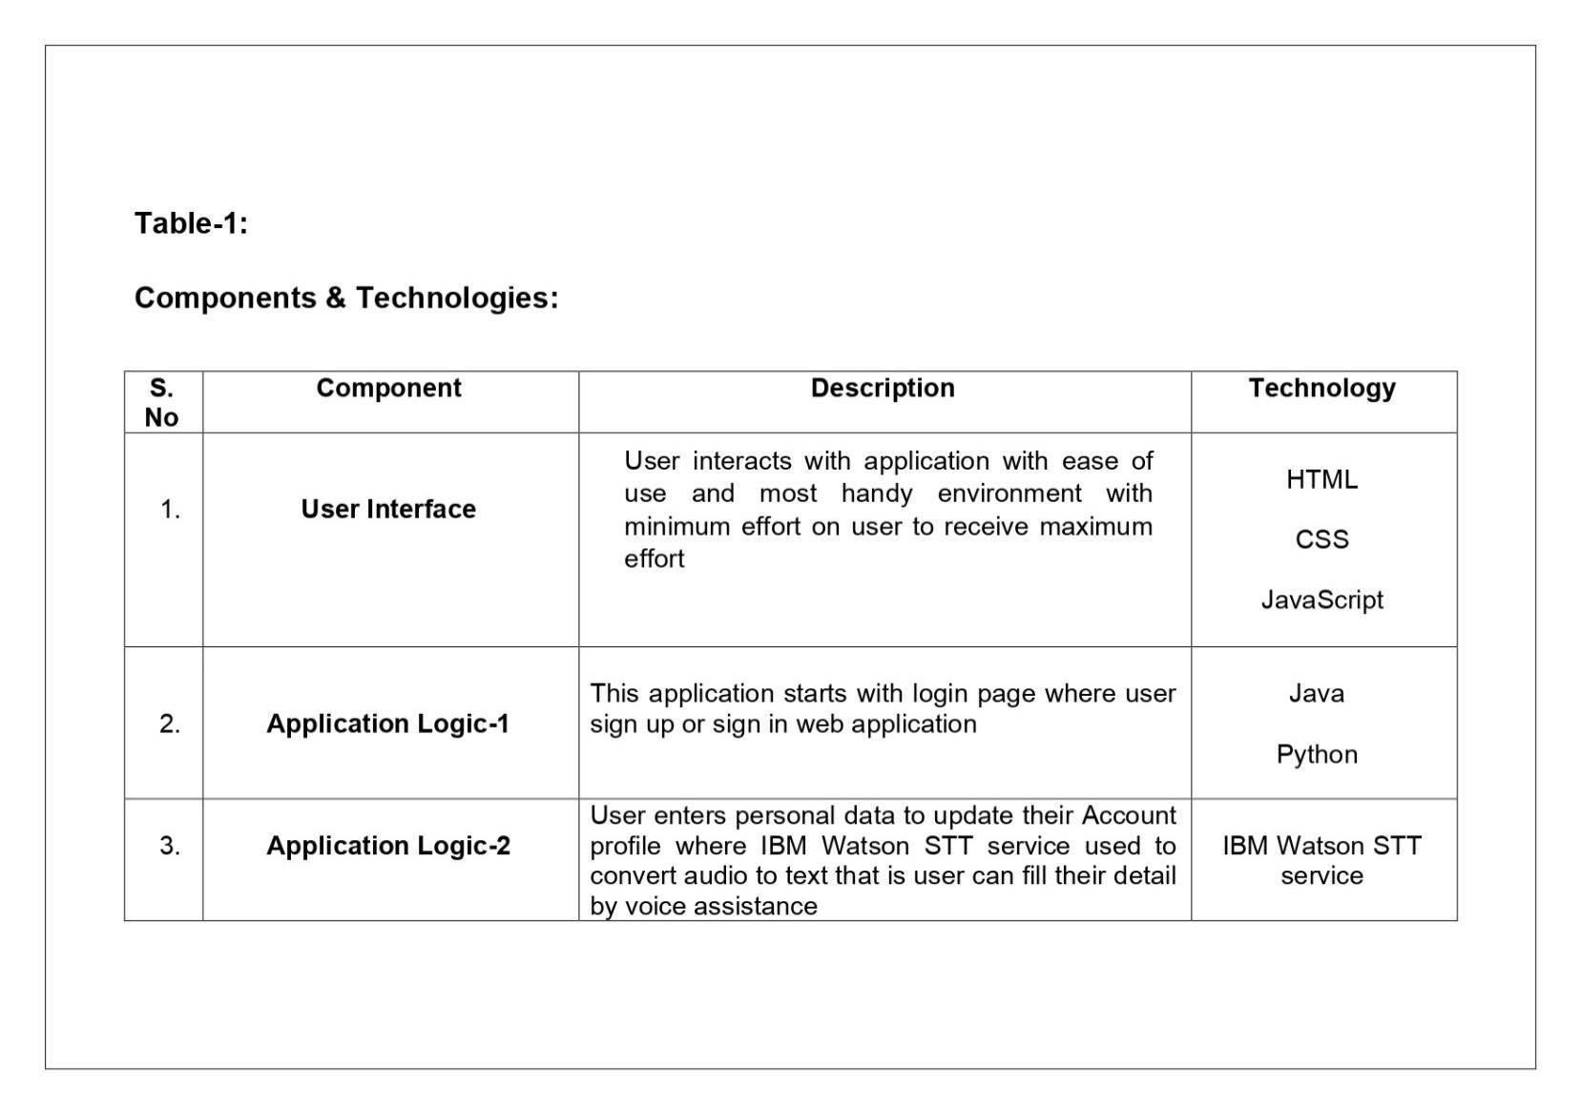

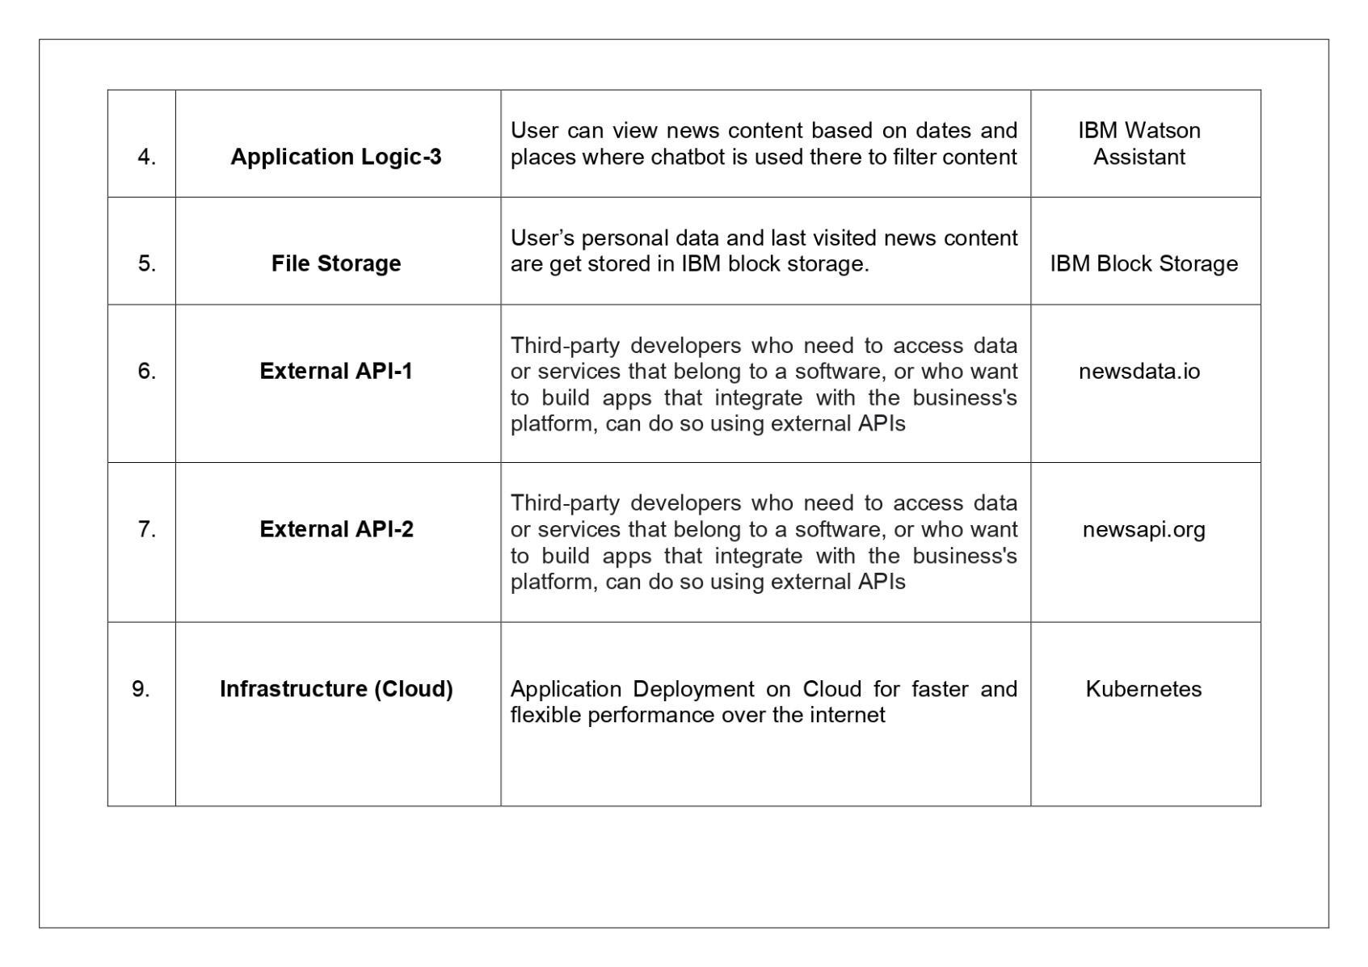

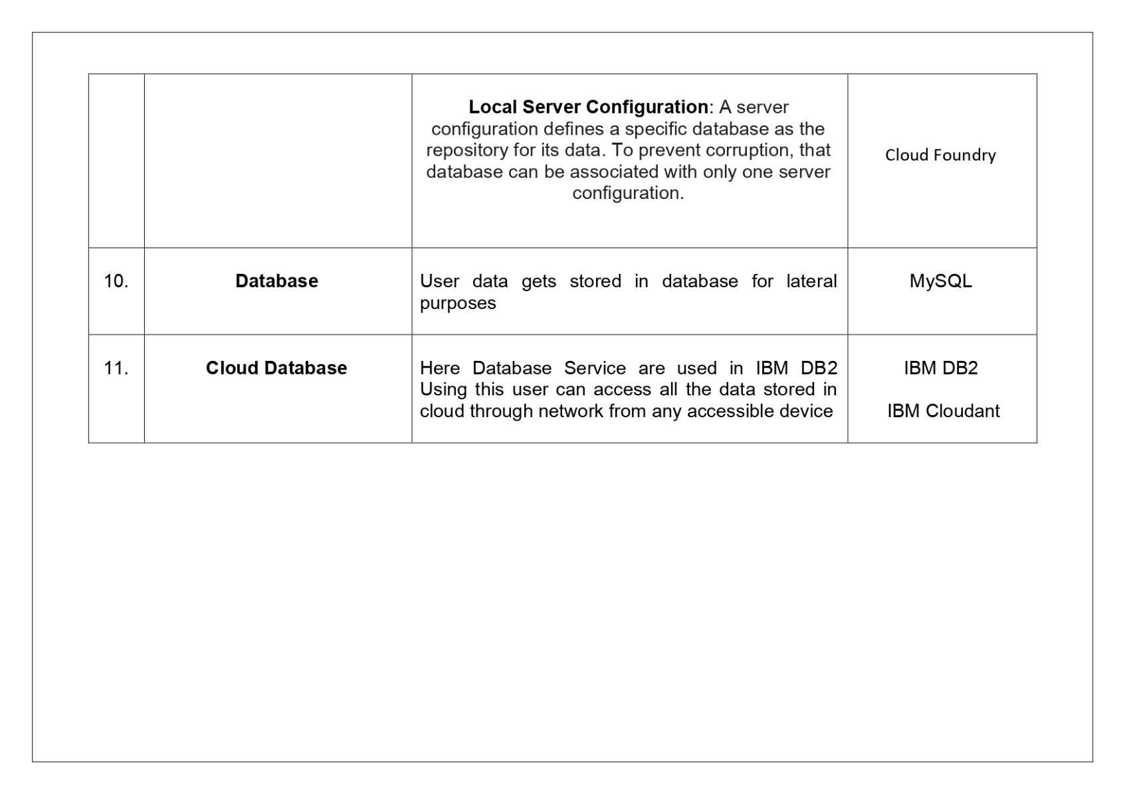

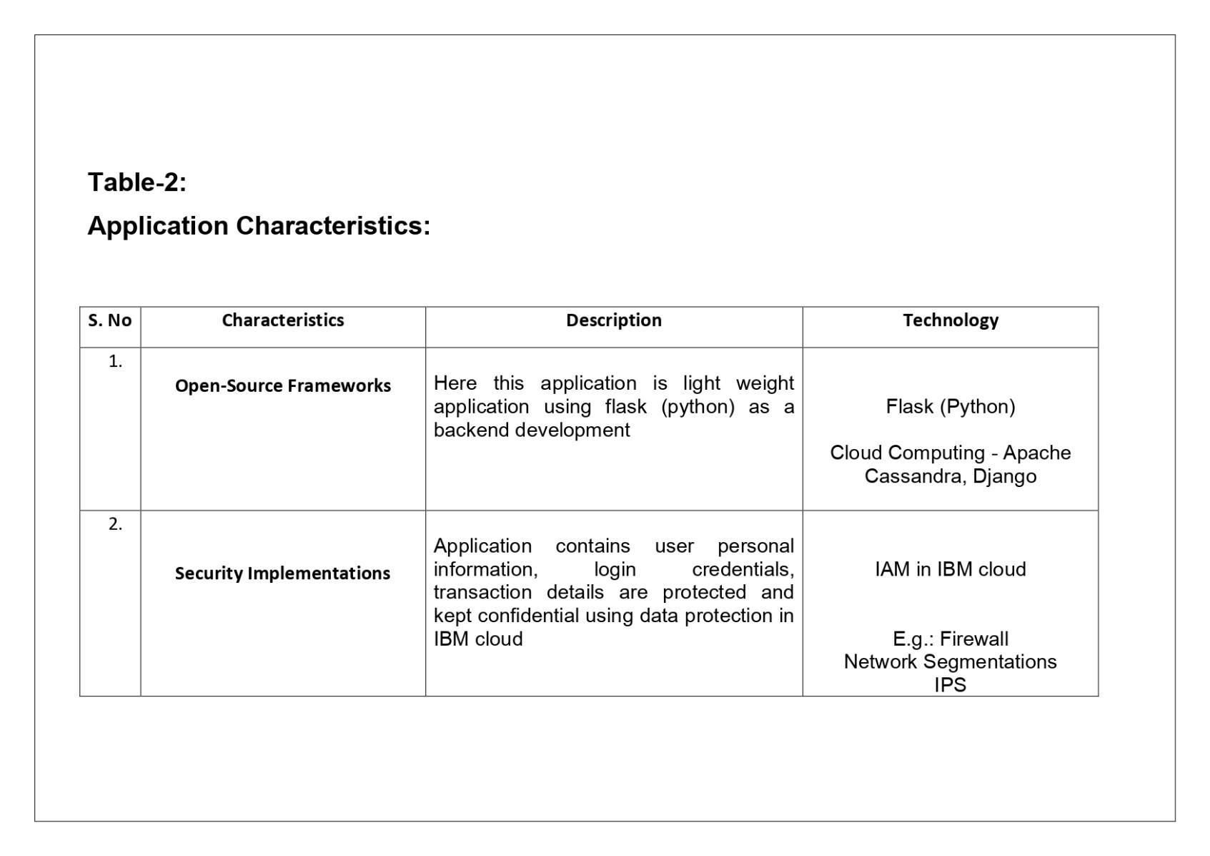

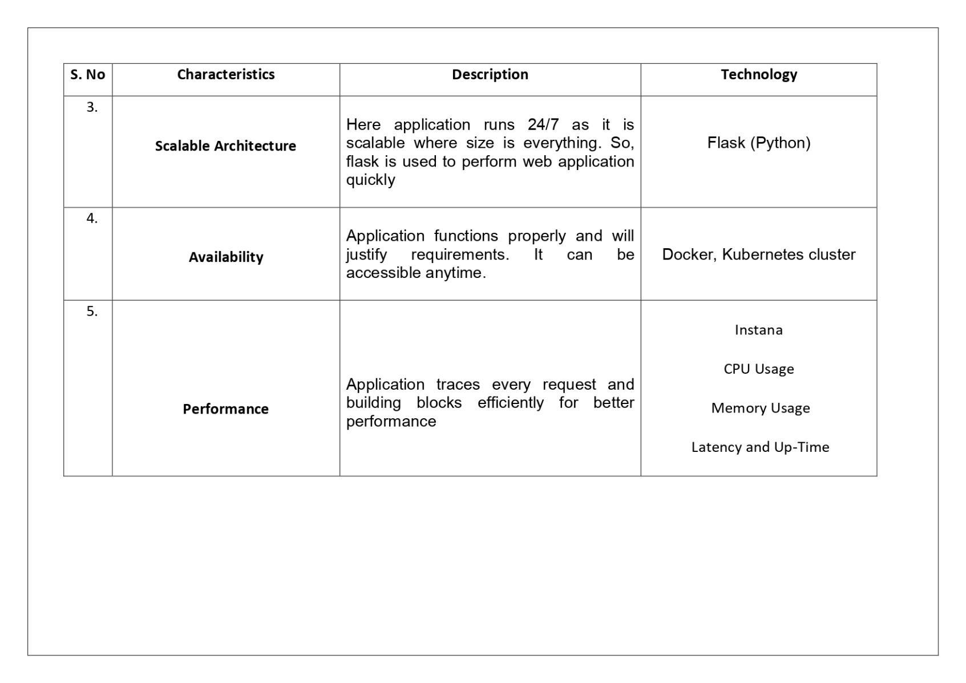

**6.PROJECT PLANNING & SCHEDULING**

**6.1 SPRINT PLANNING & ESTIMATION**

| Title | Description | Date | Completed /  In Progress |
| --- | --- | --- | --- |
| Literature Survey | Literature survey on the selected project & gathering information by referring to technical papers, research publications etc. | 2nd September 2022 | Completed |
| Prepare Empathy Map | Prepare Empathy Map Canvas to capture the user Pains & Gains, Prepare list of problem statements | 7th September 2022 | Completed |
| Ideation Brainstorming | List them by organizing the brainstorming session and prioritize the top 3 ideas based on the feasibility & importance. | 15th September 2022 | Completed |
| Proposed Solution | Prepare the proposed solution document, which includes the novelty, feasibility of idea, business model, social impact, scalability of solution, etc. | 23rd September 2022 | Completed |
| Problem Solution Fit | Prepare a solution architecture document. | 27th September 2022 | Completed |
| Solution Architecture | Prepare a solution architecture document. | 30th September 2022 | Completed |
| Customer Journey | Prepare the customer journey maps to understand the user interactions & experiences with the application (entry to exit). | 5th October 2022 | Completed |
| Solution Requirement | Prepare the functional requirement document | 12th October 2022 | Completed |
| Data Flow Diagrams | Draw the data flow diagrams and submit for review. | 15th October 2022 | Completed |
| Technology Architecture | Prepare the technology architecture diagram. | 16th October 2022 | Completed |
| Prepare Milestone & Activity List | Prepare the milestones & activity list of the project. | 21st October 2022 | Completed |
| Project Development - Delivery of  Sprint-1, 2, 3 & 4 | Develop & submit the developed code by testing it. | - | In Progress |

**6.2 SPRINT DELIVERY SCHEDULE**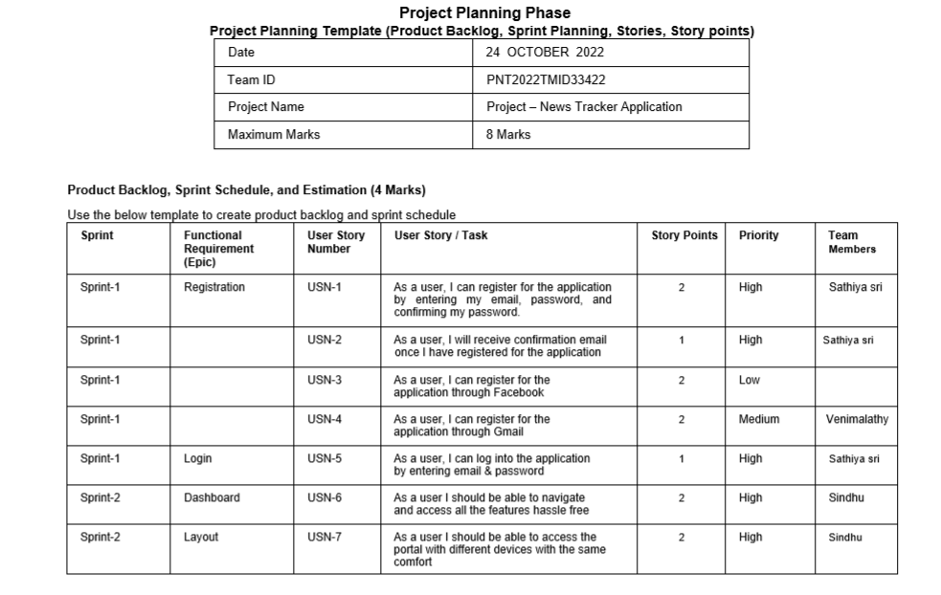

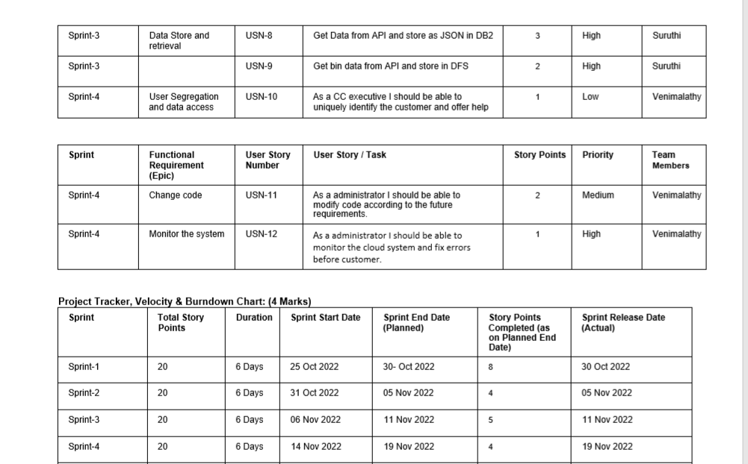

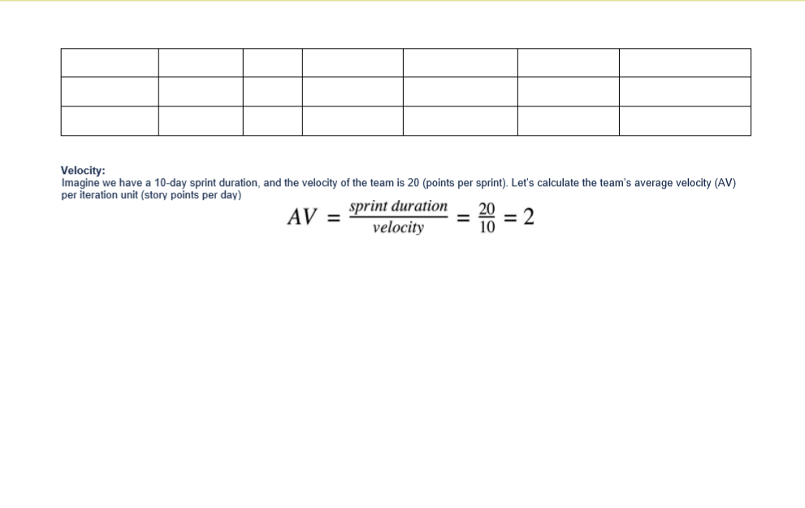

**6.3 REPORTS FROM JIRA**

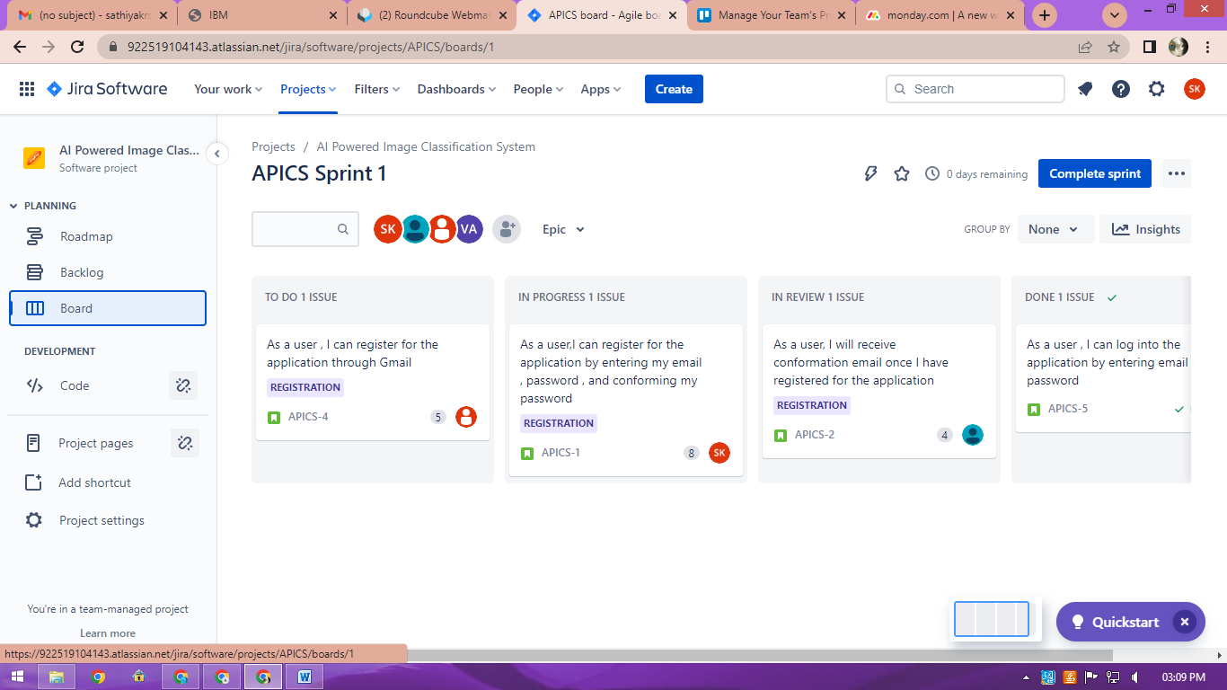



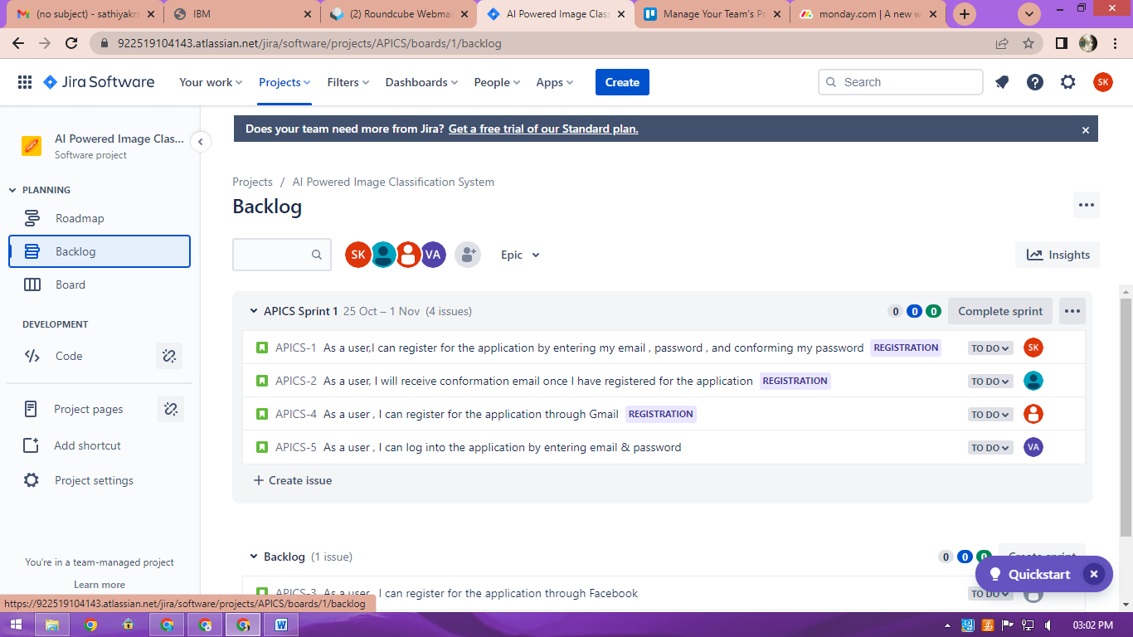

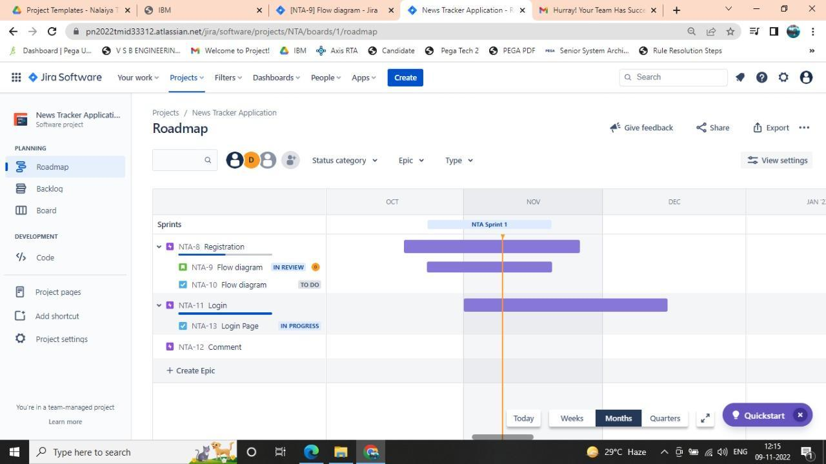

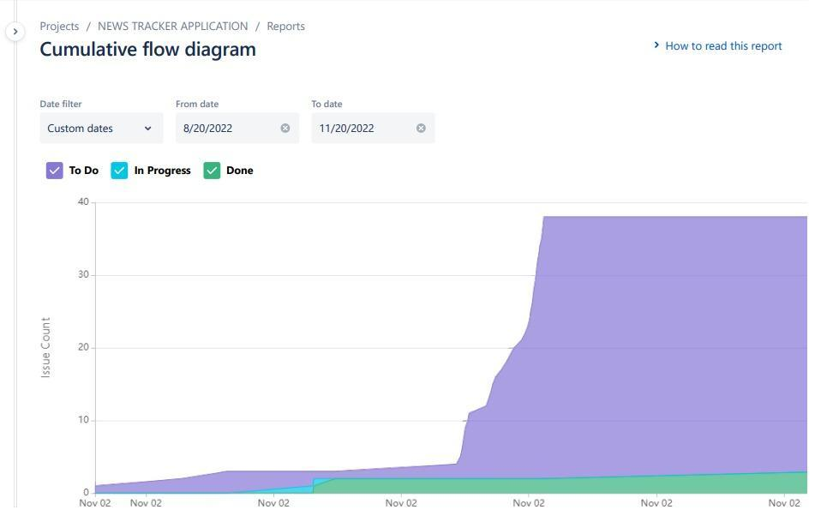

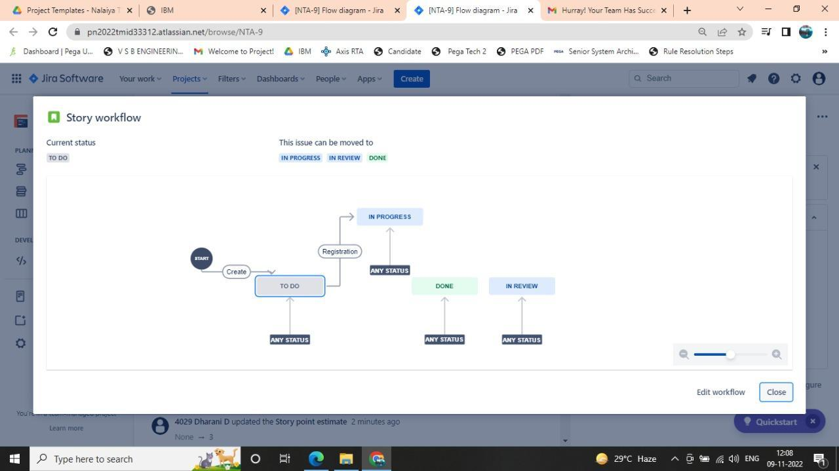

**7.CODING & SOLUTIONS**

**Home Page:**

<!DOCTYPE html>

<html lang="en">

<head>

<title>Home Page</title>

<meta charset="UTF-8">

<meta name="viewport" content="width=device-width, initial-scale=1">

<link rel="stylesheet" href="style.css">

<link rel="stylesheet" href="news.css">

</head><html>

<head>

<meta name="viewport" content="width=device-width, initial-scale=1">

<body>

<div class="navbar">

<a href="#">HOME</a>

<a href="register.html">REGISTER</a>

<a href="login.html">LOGIN</a>

</div>

<div class="header">

<div class="bg-image">

<div class="bg">

<p style="text-align:center;"><img src="Logo.png" alt="Avatar" class="avatar" align="center"></p>

<h1><p><marquee><b><i>All Information In Your Handset!Anywhere! Anyplace! Anytime!</i></b></marquee></p></h1>

</div>

</div>

</div>

<div class="container">

<div class="card">

<div class="card-header">

<img src="https://images.livemint.com/img/2021/10/30/600x338/FACEBOOK-CONNECT--50_1635590332468_1635590404753.JPG" alt="rover" />

</div>

<div class="card-body">

<a href = "Categories\world360.html"><span class="tag tag-purple">World 360°</span></a>

<h4>

<a href="https://www.firstpost.com/world/unfortunately-this-did-not-play-out-the-way-i-expected-mark-zuckerberg-as-facebook-parent-meta-cuts-11000-jobs-11598651.html" target=_blank> 'Unfortunately, This did not play out the way I expected' "Mark Zuckerberg" as Facebook parent Meta cuts 11,000 jobs</a>

</h4>

<p>

Facebook parent Meta is laying off 11,000 people, about 13 per cent of its workforce, as it contends with faltering revenue and broader tech industry woes, CEO Mark Zuckerberg said in a letter to employees Wednesday.

</p>

</div>

</div>

<div class="card">

<div class="card-header">

<img src="https://st4.depositphotos.com/2673929/25904/i/450/depositphotos_259048638-stock-photo-5g-circuit-board-with-network.jpg" alt="ballons" />

</div>

<div class="card-body">

<a href = "Categories\techworld.html"><span class="tag tag-teal">Tech - World</span></a>

<h4>

<a href="https://economictimes.indiatimes.com/industry/telecom/telecom-news/locally-made-5g-gear-to-become-available-by-march-dot-secretary/articleshow/95365090.cms" target=_blank>Locally - Made 5G gear to become available by March: DoT secretary</a>

</h4>

<p>

Full-fledged indigenously designed and developed fifth generation (5G) equipment that includes core and radio network components could be commercially available by March next year, a top official said.

</p>

</div>

</div>

<div class="card">

<div class="card-header">

<img src="https://c.ndtvimg.com/2022-11/fmvcnv3g_pakistan-beat-new-zealand-afp_625x300_09_November_22.jpg?im=FeatureCrop,algorithm=dnn,width=806,height=605" alt="city" />

</div>

<div class="card-body">

<a href = "Categories\sports.html"><span class="tag tag-pink">Sports</span></a>

<h4>

<a href="https://sports.ndtv.com/t20-world-cup-2022/watch-pakistan-greats-dance-in-studio-as-team-qualifies-for-t20-world-cup-final-by-beating-new-zealand-3504805" target=_blank>Pakistan Qualifies For T20 World Cup Final By Beating New Zealand </a>

</h4>

<p>

Once considered all but out of the T20 World Cup, the Pakistan cricket team scripted a dramatic comeback into the tournament to qualify for the semi-finals. In the penultimate round of the tournament, Pakistan outmuscled New Zealand to secure their qualification into the final.

</p>

</div>

</div>

<div class="card">

<div class="card-header">

<img src="https://th-i.thgim.com/public/incoming/yygqz6/article66110849.ece/alternates/FREE_1200/PTI10_18_2022_000072B.jpg" alt="city" />

</div>

<div class="card-body">

<a href = "Categories\inside-tn.html"><span class="tag tag-aas">Inside - TN</span></a>

<h4>

AIADMK Created By Cadres, No One Can Divide It: O Pannerselvam

</h4>

<p>

Expelled All India Anna Dravida Munnetra Kazhagam (AIADMK) leader and former chief minister of Tamil Nadu O Pannerselvam today said that AIADMK is an organization which was created by cadres and it should function with unity.</p>

</div>

</div>

<div class="card">

<div class="card-header">

<img src="https://images.hindustantimes.com/img/2022/10/11/550x309/Delhi-Weather-Rain--4_1665414049445_1665414049445_1665455613808_1665455613808.jpg" alt="city" />

</div>

<div class="card-body">

<a href = "Categories\weather360.html"><span class="tag tag-cyan">Weather 360°</span></a>

<h4>

Isolated Rains Over Rajasthan, Andhra, Karnataka; Tamil Nadu, Kerala In For Thunderstorms

</h4>

<p>

Widespread rains and thunderstorms with isolated heavy falls are likely over Andaman and Nicobar Islands.Fairly widespread rainfall with thunderstorms may lash Tamil Nadu, Puducherry and Karaikal.Dense fog is possible over Central India early in the morning. </p>

</div>

</div>

<div class="card">

<div class="card-header">

<img src="https://www.indiaspend.com/wp-content/uploads/620-Fire.jpg" alt="rover" />

</div>

<div class="card-body">

<a href = "Categories\trending today.html"><span class="tag tag-purple1">Trending Today</span></a>

<h4><a href="https://www.ndtv.com/indians-abroad/9-indians-killed-in-maldives-fire-report-3506799#trendingnow" target=_blank>9 Indians Killed In Maldives Fire: Report</a></h4>

<p>

Officials said 10 bodies were recovered from the upper floor of a building destroyed in the fire, which swept through the cramped lodgings of foreign workers.At least 10 people were killed and several others injured Thursday when a fire swept through cramped lodgings of foreign workers in the Maldives capital Male, the fire service said.

</p>

</div>

</div>

<script src="script grid.js"></script>

<br></div>

<div class="footer">

<h2>Global News</h2>

<a href="#"><ul>About us</ul></a>

<a href="#"><ul>Resources</ul></a>

<a href="#"><ul>Get started</ul></a>

<a href="#"><ul>Help</ul></a>

</div>

<script>

window.watsonAssistantChatOptions = {

integrationID: "ce85447d-0d64-4425-acc1-dfeb143cd53a", // The ID of this integration.

region: "eu-gb", // The region your integration is hosted in.

serviceInstanceID: "5de5b71c-b68b-4a41-9ebf-82cfdf531a79", // The ID of your service instance.

onLoad: function(instance) { instance.render(); }

};

setTimeout(function(){

const t=document.createElement('script');

t.src="https://web-chat.global.assistant.watson.appdomain.cloud/versions/" + (window.watsonAssistantChatOptions.clientVersion || 'latest') + "/WatsonAssistantChatEntry.js";

document.head.appendChild(t);

});

</script>

</body>

</html>

**Login.html**

<!DOCTYPE html>

<html>

<head>

<meta name="viewport" content="width=device-width, initial-scale=1">

<style>

body {font-family: Arial, Helvetica, sans-serif;

background-image: url('Newspaper.png');}

/* Full-width input fields */

input[type=text], input[type=password] {

width: 100%;

padding: 12px 20px;

margin: 8px 0;

display: inline-block;

border: 1px solid #ccc;

box-sizing: border-box;

}

/* Set a style for all buttons */

button {

background-color: #38a31a;

color: white;

padding: 14px 20px;

margin: 8px 0;

border: none;

cursor: pointer;

width: 100%;

}

button:hover {

opacity: 0.7;

}

/* Extra styles for the cancel button */

.cancelbtn {

width: auto;

padding: 10px 18px;

background-color: #ff0011;

}

/* Center the image and position the close button */

.imgcontainer {

text-align: center;

margin: 24px 0 12px 0;

position: relative;

}

img.avatar {

width: 10%;

border-radius: 20%;

}

.container {

padding: 16px;

}

span.psw {

float: right;

padding-top: 16px;

}

/* The Modal (background) */

.modal {

display: none; /* Hidden by default */

position: fixed; /* Stay in place */

z-index: 1; /* Sit on top */

left: 0;

top: 0;

width: 100%; /* Full width */

height: 100%; /* Full height */

overflow: auto; /* Enable scroll if needed */

background-color: rgb(0,0,0); /* Fallback color */

background-color: rgba(0,0,0,0.4); /* Black w/ opacity */

padding-top: 60px;

}

/* Modal Content/Box */

.modal-content {

background-color: #fefefe;

margin: 5% auto 15% auto; /* 5% from the top, 15% from the bottom and centered */

border: 1px solid #888;

width: 80%; /* Could be more or less, depending on screen size */

}

/* The Close Button (x) */

.close {

position: absolute;

right: 25px;

top: 0;

color: #000;

font-size: 35px;

font-weight: bold;

}

.close:hover,

.close:focus {

color: red;

cursor: pointer;

}

/* Add Zoom Animation */

.animate {

-webkit-animation: animatezoom 0.6s;

animation: animatezoom 0.6s

}

@-webkit-keyframes animatezoom {

from {-webkit-transform: scale(0)}

to {-webkit-transform: scale(1)}

}

@keyframes animatezoom {

from {transform: scale(0)}

to {transform: scale(1)}

}

/* Change styles for span and cancel button on extra small screens */

@media screen and (max-width: 300px) {

span.psw {

display: block;

float: none;

}

.cancelbtn {

width: 100%;

}

}

</style>

</head>

<body>

<form class="modal-content animate" action="/action_page.php" method="post">

<div class="imgcontainer">

<span onclick="document.getElementById('id01').style.display='none'" class="close" title="Close">&times;</span>

<img src="Logo.png" alt="Avatar" class="avatar">

</div>

<div class="container">

<label for="uname"><b>Username</b></label>

<input type="text" placeholder="Enter Username" name="uname" required>

<label for="psw"><b>Password</b></label>

<input type="password" placeholder="Enter Password" name="psw" required>

<button type="submit">Login</button>

<label>

<input type="checkbox" checked="checked" name="remember"> Remember Me

</label>

</div>

<div class="container" style="background-color:#f1f1f1">

<p><span class="psw">Forgot <a href="#">Password?</a></span></p>

</div>

</form>

<script>

var modal = document.getElementById('id01');

window.onclick = function(event) {

if (event.target == modal) {

modal.style.display = "none";

}

}

</script>

</body>

</html>

img.avatar {

width: 10%;

border-radius: 20%;

}

.container {

padding: 16px;

}

span.psw {

float: right;

padding-top: 16px;

}

/* The Modal (background) */

.modal {

display: none; /* Hidden by default */

position: fixed; /* Stay in place */

z-index: 1; /* Sit on top */

left: 0;

top: 0;

width: 100%; /* Full width */

height: 100%; /* Full height */

overflow: auto; /* Enable scroll if needed */

background-color: rgb(0,0,0); /* Fallback color */

background-color: rgba(0,0,0,0.4); /* Black w/ opacity */

padding-top: 60px;

}

/* Modal Content/Box */

.modal-content {

background-color: #fefefe;

margin: 5% auto 15% auto; /* 5% from the top, 15% from the bottom and centered */

border: 1px solid #888;

width: 80%; /* Could be more or less, depending on screen size */

}

/* The Close Button (x) */

.close {

position: absolute;

right: 25px;

top: 0;

color: #000;

font-size: 35px;

font-weight: bold;

}

.close:hover,

.close:focus {

color: red;

cursor: pointer;

}

/* Add Zoom Animation */

.animate {

-webkit-animation: animatezoom 0.6s;

animation: animatezoom 0.6s

}

@-webkit-keyframes animatezoom {

from {-webkit-transform: scale(0)}

to {-webkit-transform: scale(1)}

}

@keyframes animatezoom {

from {transform: scale(0)}

to {transform: scale(1)}

}

/* Change styles for span and cancel button on extra small screens */

@media screen and (max-width: 300px) {

span.psw {

display: block;

float: none;

}

.cancelbtn {

width: 100%;

}

}

</style>

</head>

<body>

<form class="modal-content animate" action="/action_page.php" method="post">

<div class="imgcontainer">

<span onclick="document.getElementById('id01').style.display='none'" class="close" title="Close">&times;</span>

<img src="Logo.png" alt="Avatar" class="avatar">

</div>

<div class="container">

<label for="uname"><b>Username</b></label>

<input type="text" placeholder="Enter Username" name="uname" required>

<label for="psw"><b>Password</b></label>

<input type="password" placeholder="Enter Password" name="psw" required>

<button type="submit">Login</button>

<label>

<input type="checkbox" checked="checked" name="remember"> Remember Me

</label>

</div>

<div class="container" style="background-color:#f1f1f1">

<p><span class="psw">Forgot <a href="#">Password?</a></span></p>

</div>

</form>

<script>

var modal = document.getElementById('id01');

window.onclick = function(event) {

if (event.target == modal) {

modal.style.display = "none";

}

}

</script>

</body>

</html>

**News.css**

@import url("https://fonts.googleapis.com/css2?family=Roboto&display=swap");

* {

box-sizing: border-box;

}

body {

display: absolute;

justify-content: center;

align-items: center;

margin: 0;

background-color: #f7f8fc;

font-family: "Roboto", sans-serif bold;

color: #10182f;

}

img {

border-radius: 4px;

padding: 5px;

width: 100px;

}

nav{

display: flex;

align-items: center;

justify-content: space-between;

}

ul{

display: flex;

}

li{

list-style: none;

margin: 1rem;

margin-right: 25px;

margin-left: 25px ;

}

a{

text-decoration: none;

color: rgb(49, 49, 47);

}

a:hover {

text-decoration: none;

color: #daa800;

opacity: 0.8;

transition: 1s;

}

.container {

display: flex;

width: 1040px;

justify-content: space-evenly;

flex-wrap: wrap;

}

.card {

margin: 10px;

background-color: #fff;

border-radius: 10px;

box-shadow: 0 2px 20px rgba(0, 0, 0, 0.2);

overflow: hidden;

width: 300px;

height: 460px;

}

.card-header img {

width: 100%;

height: 200px;

object-fit: cover;

}

.card-body {

display: flex;

flex-direction: column;

justify-content: center;

align-items: flex-start;

padding: 20px;

min-height: 250px;

}

.tag {

background: #cccccc;

border-radius: 50px;

font-size: 12px;

margin: 0;

color: #fff;

padding: 2px 10px;

text-transform: uppercase;

cursor: pointer;

}

.tag-teal {

background-color: #15bfc2;

}

.tag-purple {

background-color: #e8570e;

}

.tag-purple1 {

background-color: #139427;

}

.tag-pink {

background-color: #e813c8;

}

.tag-cyan{

background-color: #3d13e8;

}

.tag-aas{

background-color: #fa0202;

}

.card-body p {

font-size: 13px;

margin: 0 0 40px;

}

.user {

display: flex;

margin-top: auto;

margin-right: 20px;

margin-top: 5px;

}

.user img {

border-radius: 500%;

width: 40px;

height: 40px;

margin-right: 10px;

}

.user-info h5 {

margin: 1;

margin-top: 5px;

}

.user-info small {

color: black;

}

**Register.html**

<!DOCTYPE html>

<html>

<head>

<meta name="viewport" content="width=device-width, initial-scale=1">

<style>

body {

font-family: Arial, Helvetica, sans-serif;

background-color: black;

}

* {

box-sizing: border-box;

}

/* Add padding to containers */

.container {

padding: 16px;

background-color: white;

}

/* Full-width input fields */

input[type=text], input[type=password] {

width: 100%;

padding: 15px;

margin: 5px 0 22px 0;

display: inline-block;

border: none;

background: #f1f1f1;

}

input[type=text]:focus, input[type=password]:focus {

background-color: #ddd;

outline: none;

}

/* Overwrite default styles of hr */

hr {

border: 1px solid #f1f1f1;

margin-bottom: 25px;

}

/* Set a style for the submit button */

.registerbtn {

background-color: #38a31a;

color: white;

padding: 16px 20px;

margin: 8px 0;

border: none;

cursor: pointer;

width: 100%;

opacity: 0.9;

}

.registerbtn:hover {

opacity: 1;

}

/* Add a blue text color to links */

a {

color: dodgerblue;

}

/* Set a grey background color and center the text of the "sign in" section */

.signin {

background-color: #ffffff;

text-align: center;

}

</style>

</head>

<body>

<form action="/action_page.php">

<div class="container">

<h1>Register</h1>

<p>Create an Account to Connect With News Tracker Application!</p>

<hr>

<label for="email"><b>Email</b></label>

<input type="text" placeholder="Enter Email ID" name="email" id="email" required>

<label for="psw"><b>Password</b></label>

<input type="password" placeholder="Password Should Be (8-16) Characters" name="psw" id="psw" required>

<label for="psw-repeat"><b>Repeat Password</b></label>

<input type="password" placeholder="Repeat Password" name="psw-repeat" id="psw-repeat" required>

<hr>

<p>By Creating an Account you Agree to Our <a href="#">Terms & Privacy</a>.</p>

<button type="submit" class="registerbtn">Register</button>

</div>

<div class="container signin">

<p>Already an Existing User? <a href="login.html">Sign in</a>.</p>

</div>

</form>

</body>

</html>

**Style.css**

* {

box-sizing: border-box;

}

body {

font-family: Arial, Helvetica, sans-serif;

margin: 0;

}

body, html {

height: 100%;

margin: 0;

font-family: Arial, Helvetica, sans-serif;

}

* {

box-sizing: border-box;

}

.bg-image {

background-image: url("news.png");

height: 100%;

background-position: center;

background-repeat: no-repeat;

background-size: cover;

}

.bg{

color:white;

display: block;

margin-left: auto;

margin-right: auto;

}

}

.header {

background-image:url("news.png") no-repeat;

height: 60%;

background-position: center;

background-repeat: no-repeat;

background-size: cover;

position: relative;

text-align: center;

}

.header h1 {

font-size: 30px;

}

img.avatar {

width: 10%;

border-radius: 20%;

}

.navbar {

overflow: hidden;

background-color: #43255e;

}

.navbar a {

float: left;

display: block;

color: white;

text-align: center;

padding: 14px 20px;

text-decoration: none;

}

.navbar a.right {

float: right;

}

.navbar a:hover {

background-color: #ddd;

color: black;

}

.footer {

padding: 20px;

color: black;

background: #ffffff;

margin-top:70%;

}

@media screen and (max-width: 700px) {

.row {

flex-direction: column;

}

}

@media screen and (max-width: 400px) {

.navbar a {

float: none;

width: 100%;

}

}

* {

box-sizing: border-box;

}

body {

background-color: #f1f1f1;

padding: 20px;

font-family: Arial;

}

/* Center website */

.main {

max-width: 1000px;

margin: auto;

}

h1 {

font-size: 50px;

word-break: break-all;

}

.row {

margin: 10px -16px;

}

/* Add padding BETWEEN each column */

.row,

.row > .column {

padding: 8px;

}

/* Create three equal columns that floats next to each other */

.column {

float: left;

width: 33.33%;

display: none; /* Hide all elements by default */

}

/* Clear floats after rows */

.row:after {

content: "";

display: table;

clear: both;

}

/* Content */

.content {

background-color: white;

padding: 10px;

}

/* The "show" class is added to the filtered elements */

.show {

display: block;

}

Inside – TN.html

<!DOCTYPE html>

<html lang="en">

<head>

<meta charset="UTF-8">

<meta http-equiv="X-UA-Compatible" content="IE=edge">

<meta name="viewport" content="width=device-width, initial-scale=1.0">

<title>Inside-TN</title>

<link rel="stylesheet" href="news.css">

</head>

<body>

<nav>

<div class="Logo">

<ul>

<img src="Logo.png" alt="LOGO" />

</ul>

</div>

<div class="menu">

<ul>

<li> <a href="news.html"> Home</a></li>

<li> <a href="#"> About</a></li>

<div class="user">

<img src="Profile Logo.png" alt="user" />

<div class="user-info">

</div>

</div>

</ul>

</div>

</nav>

<hr width="900%" style="border: 3px solid #f20f0f; margin-top: 10px;margin-bottom: 20px;">

<h1><center>Inside-TN</h1>

<div class="container">

<div class="card">

<div class="card-header">

<img src="https://c.ndtvimg.com/2022-10/49bk5kpg_nia-coimbatore_625x300_30_October_22.jpg" alt="rover" />

</div>

<div class="card-body">

<span class="tag tag-purple">Inside-TN</span>

<h4>

<a href="https://www.ndtv.com/tamil-nadu-news/anti-terror-agency-probing-coimbatore-car-blast-raids-45-locations-in-tamil-nadu-3506378" target=_blank>Anti-Terror Agency Probing Coimbatore Car Blast Raids 45 Locations</a>

</h4>

<p>

New Delhi: The National Investigation Agency (NIA) has been conducting searches at 45 locations in Tamil Nadu in connection with its ongoing probe into October 23 Coimbatore LPG cylinder explosion that occurred in a car, sources said today.A 29-year-old man Jameesha Mubin was killed in a car explosion.

</p>

</div>

</div>

<div class="card">

<div class="card-header">

<img src="https://c.ndtvimg.com/65ep5ff8_businessman-arrest-generic-istock_625x300_01_September_18.jpg" alt="rover" />

</div>

<div class="card-body">

<span class="tag tag-purple">Inside-TN</span>

<h4>

<a href="https://www.ndtv.com/chennai-news/chennai-man-forges-rbi-permission-letter-to-run-bank-arrested-3503820" target=_blank>Chennai Man Forges RBI Permission Letter To Run Bank, Arrested</a>

</h4>

<p>

Chennai: The Chennai Police has arrested a person for forging RBI permission certificate for running a bank in different parts of the state.Fake passbooks, deposit forms, debit and credit cards among others were found in his possession, a police release said.

</p>

</div>

</div>

<div class="card">

<div class="card-header">

<img src="https://c.ndtvimg.com/2021-06/i1030bgc_drone-generic_625x300_30_June_21.jpg" alt="rover" />

</div>

<div class="card-body">

<span class="tag tag-purple">Inside-TN</span>

<h4>

<a href="https://www.ndtv.com/tamil-nadu-news/tamil-nadu-aims-to-have-2-500-drone-pilots-a-year-report-3501248" target=_blank>Tamil Nadu Aims To Have 2,500 Drone Pilots A Year: Report</a>

</h4>

<p>

A memorandum of understanding was signed between senior executives of Tamil Nadu Industrial Development Corporation (TIDCO) IGRUA, De Drone World Solutions in the presence of Chief Minister M K Stalin at an event here.

</p>

</div>

</div>

<div class="card">

<div class="card-header">

<img src="https://c.ndtvimg.com/2022-11/cj805b3o_kerala-journalists-protest-against-governor_625x300_08_November_22.jpg" alt="rover" />

</div>

<div class="card-body">

<span class="tag tag-purple">Inside-TN</span>

<h4>

<a href="https://www.ndtv.com/india-news/puppet-of-centre-3-southern-state-governments-clash-with-governors-3500591" target=_blank>"Puppet Of Centre": 3 Southern State Governments Clash With Governors</a>

</h4>

<p>

Hyderabad: A major fight is brewing in the southern states of Kerala, Tamil Nadu, and Telangana between the Governors and the ruling parties.The Governors in the three states have been accused of acting like "puppets of the Centre" by state governments who have had several run-ins with them on key legislation.

</p>

</div>

</div>

<div class="card">

<div class="card-header">

<img src="https://c.ndtvimg.com/2022-06/ars722ac_police-generic_625x300_14_June_22.jpg" alt="rover" />

</div>

<div class="card-body">

<span class="tag tag-purple">Inside-TN</span>

<h4>

<a href="https://www.ndtv.com/india-news/six-arrested-for-assaulting-50-year-old-man-in-madurai-police-3494688" target=_blank>Six Arrested For Assaulting 50-Year-Old Man In Madurai: Police</a>

</h4>

<p>

Madurai: Six out of seven people were arrested over assaulting a 50-year-old person, while he came to pick up his daughter in Madurai Meenal Women College in Tamil Nadu's Madurai.

</p>

</div>

</div>

<div class="card">

<div class="card-header">

<img src="https://c.ndtvimg.com/2022-11/f553fam_rss-tamil-nadu-march_625x300_06_November_22.jpg" alt="rover" />

</div>

<div class="card-body">

<span class="tag tag-purple">Inside-TN</span>

<h4>

<a href="https://www.ndtv.com/tamil-nadu-news/rss-holds-marches-in-3-tamil-nadu-districts-amid-tight-security-3495774" target=_blank>RSS Holds Marches In 3 Tamil Nadu Districts Amid Tight Security</a>

</h4>

<p>

Chennai: The Rashtriya Swayamsevak Sangh, or RSS, held marches in Tamil Nadu's Kallakurichi, Cuddalore and Perambalur districts today, a day after the BJP's ideological mentor said it was cancelling the event, following a hearing in the Madras High Court.

</p>

</div>

</div>

</div>

</body>

</html>

**Sports.html**

<!DOCTYPE html>

<html lang="en">

<head>

<meta charset="UTF-8">

<meta http-equiv="X-UA-Compatible" content="IE=edge">

<meta name="viewport" content="width=device-width, initial-scale=1.0">

<title>Sports</title>

<link rel="stylesheet" href="news.css">

</head>

<body>

<nav>

<div class="Logo">

<ul>

<img src="Logo.png" alt="LOGO" />

</ul>

</div>

<div class="menu">

<ul>

<li> <a href="news.html"> Home</a></li>

<li> <a href="#"> About</a></li>

<div class="user">

<img src="Profile Logo.png" alt="user" />

<div class="user-info">

</div>

</div>

</ul>

</div>

</nav>

<hr width="900%" style="border: 3px solid #f20f0f; margin-top: 10px;margin-bottom: 20px;">

<h1><center>Sports</h1>

<div class="container">

<div class="card">

<div class="card-header">

<img src="https://c.ndtvimg.com/2022-11/bpa5eom_henrik-mkhitaryan-afp_625x300_10_November_22.jpg?im=FeatureCrop,algorithm=dnn,width=806,height=605" alt="rover" />

</div>

<div class="card-body">

<span class="tag tag-purple">Sports</span>

<h4>

<a href="https://sports.ndtv.com/football/inter-milan-crush-bologna-as-atalanta-roma-slip-up-again-3506715" target=_blank>Inter Milan Crush Bologna As Atalanta, Roma Slip Up Again</a>

</h4>

<p>

Inter Milan climbed into the top four in Serie A on Wednesday with a 6-1 thrashing of Bologna, while Atalanta slumped to a third defeat in four games at Lecce. Seeking a fourth league win in a row, Bologna took the lead at the San Siro through Charalampos Lykogiannis' deflected shot on 22 minutes.

</p>

</div>

</div>

<div class="card">

<div class="card-header">

<img src="https://www.prokabaddi.com/static-assets/waf-images/3b/db/ca/16-9/9vsPNZkqTG.jpg?v=2.03&w=750" alt="rover" />

</div>

<div class="card-body">

<span class="tag tag-purple">Sports</span>

<h4>

<a href="https://www.prokabaddi.com/news/match-69-report-pkl-season-9-tamil-thalaivas-puneri-paltan" target=_blank>Puneri Paltan stage dramatic comeback to beat Tamil Thalaivas</a>

</h4>

<p>

Fazel Atrachali fulfilled two promises, one to beat Tamil Thalaivas and the second to catch Narender out for his 400th tackle point in vivo Pro Kabaddi, all in one game as Puneri Paltan beat Tamil Thalaivas 35-34 at the Shree Shivchhatrapati Sports Complex, Balewadi in Pune on Wednesday.

</p>

</div>

</div>

<div class="card">

<div class="card-header">

<img src="https://c.ndtvimg.com/2022-07/he14kjng_savita-punia-twitter_625x300_12_July_22.jpg?im=FeatureCrop,algorithm=dnn,width=806,height=605" alt="rover" />

</div>

<div class="card-body">

<span class="tag tag-purple">Sports</span>

<h4>

<a href="https://sports.ndtv.com/hockey/savita-punia-to-lead-india-womens-hockey-team-in-fih-nations-cup-in-december-navjot-kaur-makes-comeback-3504095" target=_blank>Savita Punia To Lead India Women's Hockey Team In FIH Nations Cup In December, Navjot Kaur Makes Comeback</a>

</h4>

<p>

India on Wednesday named a 20-member team for the women's FIH Nations Cup hockey tournament to be played in Valencia, Spain from December 11 to 17 with midfielder Navjot Kaur making a return after missing out the Commonwealth Games earlier this year.

</p>

</div>

</div>

<div class="card">

<div class="card-header">

<img src="https://c.ndtvimg.com/2022-08/aei8keg_rafael-nadal-afp_625x300_31_August_22.jpg?im=FeatureCrop,algorithm=dnn,width=806,height=605" alt="rover" />

</div>

<div class="card-body">

<span class="tag tag-purple">Sports</span>

<h4>

<a href="https://sports.ndtv.com/tennis/rafael-nadal-iga-swiatek-to-begin-2023-at-united-cup-in-australia-3506360" target=_blank>Rafael Nadal, Iga Swiatek To Begin 2023 At United Cup In Australia</a>

</h4>

<p>

Rafael Nadal and Iga Swiatek will kick off their 2023 seasons at the United Cup in Australia, a new mixed teams event, but a host of top 10 players are skipping the tournament. The United Cup, with US$15 million in prize money and rankings points at stake, has replaced the men's ATP Cup and will be held in Brisbane, Perth and Sydney as a key build-up to the Australian Open Grand Slam.

</p>

</div>

</div>

<div class="card">

<div class="card-header">

<img src="https://images.indianexpress.com/2014/03/Virat-Kohli-1.jpg" alt="rover" />

</div>

<div class="card-body">

<span class="tag tag-purple">Sports</span>

<h4>

<a href="https://indianexpress.com/article/sports/cricket/virat-kohli-becomes-the-first-to-score-4000-t20i-runs-8260571/" target=_blank>T20 Virat Kohli becomes the first to score 4000 T20I runs, leaps past Brian Lara as the overseas batter with most runs at Adelaide Oval</a>

</h4>

<p>

Scoring 50 off 40 deliveries in the second semifinal of the 2022 T20 World Cup, Virat Kohli became the first batter to cross the 4000 T20I run mark. The former India captain was also the first to breach the 3000 run mark in the shortest format for India.

</p>

</div>

</div>

<div class="card">

<div class="card-header">

<img src="https://c.ndtvimg.com/2022-08/uohdn22_taapsee-pannu_625x300_11_August_22.jpeg?im=FeatureCrop,algorithm=dnn,width=806,height=605" alt="rover" />

</div>

<div class="card-body">

<span class="tag tag-purple">Sports</span>

<h4>

<a href="https://sports.ndtv.com/cricket/taapsee-pannu-anushka-sharma-laud-bccis-decision-of-equal-match-fee-for-men-and-women-3467138" target=_blank>Taapsee Pannu, Anushka Sharma Praise BCCI's Decision Of Equal Match Fee For Men And Women</a>

</h4>

<p>

Bollywood stars Taapsee Pannu and Anushka Sharma on Thursday welcomed the BCCI's landmark decision of equal match fee for its centrally-contracted female and male players in a bid to promote gender equality in cricket. As per the newly introduced system.

</p>

</div>

</div>

</div>

</body>

</html>

**Techworld.html**

<!DOCTYPE html>

<html lang="en">

<head>

<meta charset="UTF-8">

<meta http-equiv="X-UA-Compatible" content="IE=edge">

<meta name="viewport" content="width=device-width, initial-scale=1.0">

<title>Tech world</title>

<link rel="stylesheet" href="news.css">

</head>

<body>

<nav>

<div class="Logo">

<ul>

<img src="Logo.png" alt="LOGO" />

</ul>

</div>

<div class="menu">

<ul>

<li> <a href="news.html"> Home</a></li>

<li> <a href="#"> About</a></li>

<div class="user">

<img src="Profile Logo.png" alt="user" />

<div class="user-info">

</div>

</div>

</ul>

</div>

</nav>

<hr width="900%" style="border: 3px solid #f20f0f; margin-top: 10px;margin-bottom: 20px;">

<h1><center>TECH World!</h1>

<div class="container">

<div class="card">

<div class="card-header">

<img src="https://images.indianexpress.com/2022/11/ElonMusk_TwitterProfile_1.jpg" alt="rover" />

</div>

<div class="card-body">

<span class="tag tag-purple">Tech World</span>

<h4>

<a href="https://indianexpress.com/article/technology/tech-news-technology/elon-musk-twitter-blue-with-paid-verifications-starts-rolling-out-and-theres-chaos-8260022/" target=_blank>Twitter Blue with paid verifications starts rolling out, and there’s chaos</a>

</h4>

<p>

“Please note that Twitter will do lots of dumb things in coming months. We will keep what works & change what doesn’t. (sic),” tweeted Elon Musk last night as the company’s Twitter Blue subscription service started to roll out. The new subscription plan lets anyone get verified for the price of $8 price in the US.

</p>

</div>

</div>

<div class="card">

<div class="card-header">

<img src="https://images.indianexpress.com/2022/11/Asus-Fold-FB.jpg" alt="rover" />

</div>

<div class="card-body">

<span class="tag tag-purple">Tech World</span>

<h4>

<a href="https://indianexpress.com/article/technology/tech-news-technology/foldable-laptops-will-have-a-similar-market-trajectory-as-foldable-phones-asus-india-executive-8258400/" target=_blank>‘Foldable laptops will have a similar market trajectory as foldable phones’: Asus India executive</a>

</h4>

<p>

Arnold Su, Business Head, Consumer and Gaming PC, System Business Group, Asus India, sees a similar market trajectory for foldable laptops as foldable phones. “If you go back to the foldable phone segment four years back, it was a niche product category, but gradually the market has expanded,” Su told indianexpress.com in an interview.

</p>

</div>

</div>

<div class="card">

<div class="card-header">

<img src="https://images.indianexpress.com/2022/11/Zuckerberg_AP_1.jpg" alt="rover" />

</div>

<div class="card-body">

<span class="tag tag-purple">Tech World</span>

<h4>

<a href="https://indianexpress.com/article/technology/tech-news-technology/mark-zuckerberg-message-meta-job-cuts-layoffs-employees-impacted-8259093/" target=_blank>Immigration help for those on visas to healthcare: Zuckerberg’s message after Meta layoffs</a>

</h4>

<p>

Meta Wednesday announced it will let go of more than 11,000 employees or 13 per cent of its total workforce, in one of the biggest layoffs in the US this year. In a blog post posted on the company’s official newsroom, Meta CEO and co-founder Mark Zuckerberg.”

</p>

</div>

</div>

<div class="card">

<div class="card-header">

<img src="https://images.indianexpress.com/2022/11/FTX-Binance-20221110.jpg" alt="rover" />

</div>

<div class="card-body">

<span class="tag tag-purple">Tech World</span>

<h4>

<a href="https://indianexpress.com/article/technology/crypto/ftx-binance-takeover-crypto-market-8260361/" target=_blank>Behind FTX’s fall, battling billionaires and a failed bid to save crypto</a>

</h4>

<p>

The reason for the mea culpa: His announcement half an hour earlier that FTX’s arch-rival, Binance, planned to mount a shock takeover of its main trading platform to save it from a “liquidity crunch.” Binance founder Changpeng “CZ” Zhao, whom the billionaire had accused of sabotage, would now be his White Knight.

</p>

</div>

</div>

<div class="card">

<div class="card-header">

<img src="https://images.indianexpress.com/2022/11/YouTube.jpg" alt="rover" />

</div>

<div class="card-body">

<span class="tag tag-purple">Tech World</span>

<h4>

<a href="https://indianexpress.com/article/technology/techook/youtube-premium-and-music-crosses-80-million-user-mark-heres-how-to-get-it-8260385/" target=_blank>YouTube Premium and Music crosses 80 million user mark: Here’s how to get it</a>

</h4>

<p>

In a recent blog post, YouTube announced that it has more than 80 million Premium and Music subscribers worldwide. In September last year, the video streaming platform surpassed the 50 million mark. YouTube Premium’s growth has been nothing short of impressive.

</p>

</div>

</div>

<div class="card">

<div class="card-header">

<img src="https://images.indianexpress.com/2022/11/Cygnus-cargo-ship-20221110.jpg" alt="rover" />

</div>

<div class="card-body">

<span class="tag tag-purple">Tech World</span>

<h4>

<a href="https://indianexpress.com/article/technology/science/nasa-cygnus-cargo-ship-international-space-station-8260201/" target=_blank>Cargo ship reaches space station despite jammed solar panel</a>

</h4>

<p>

A Northrop Grumman capsule delivered several tons of supplies to the International Space Station on Wednesday despite a jammed solar panel. The shipment arrived two days after launching from Virginia.

</p>

</div>

</div>

</div>

</body>

</html>

**8.TESTING**

**8.1 TEST CASE**

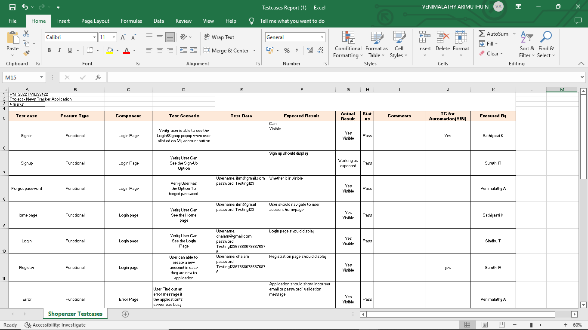

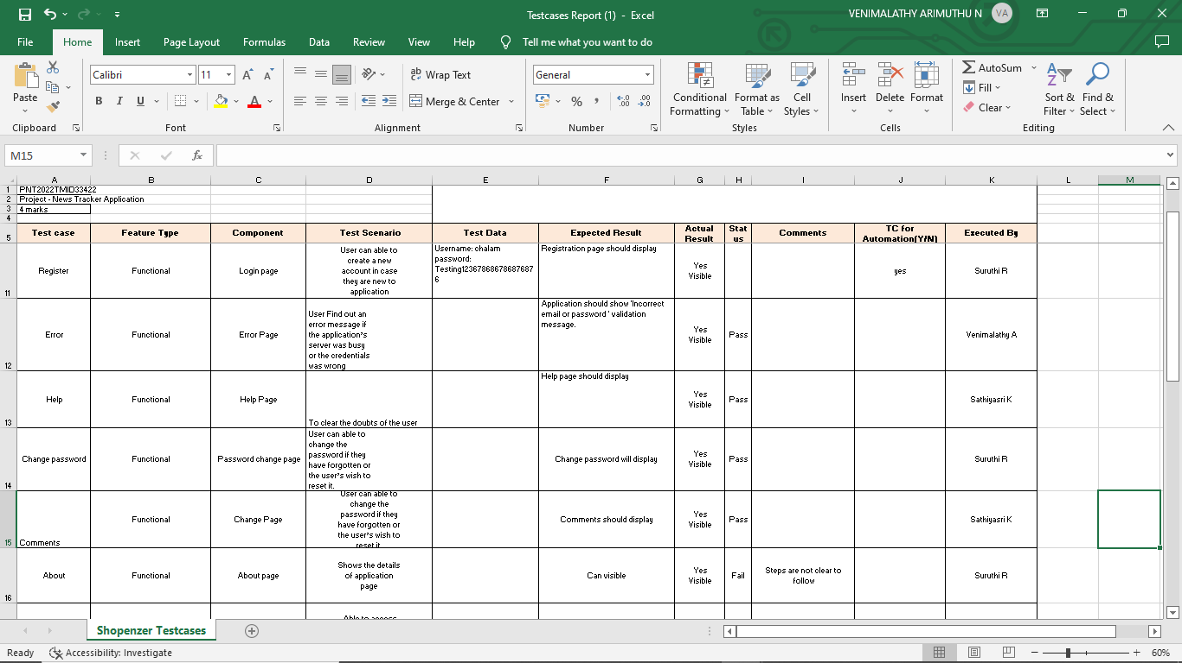

**8.2 USER ACCEPTANCE TESTING**

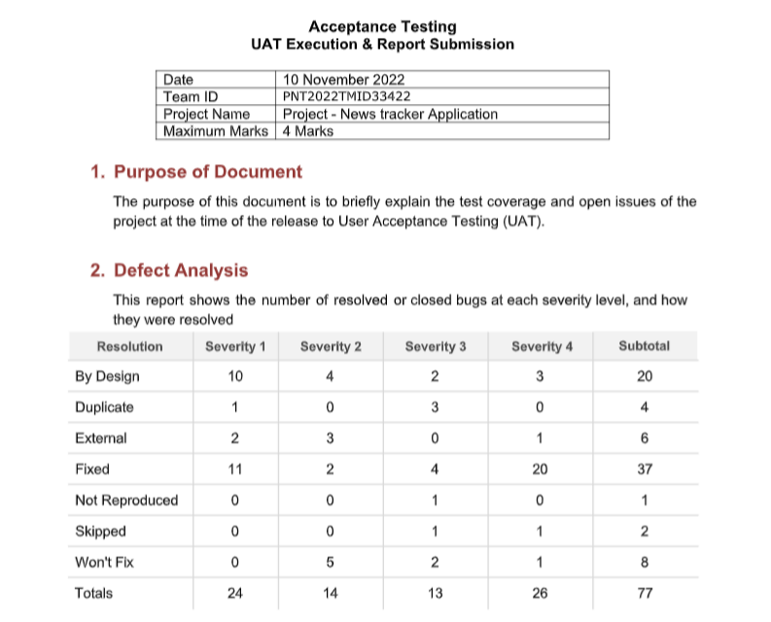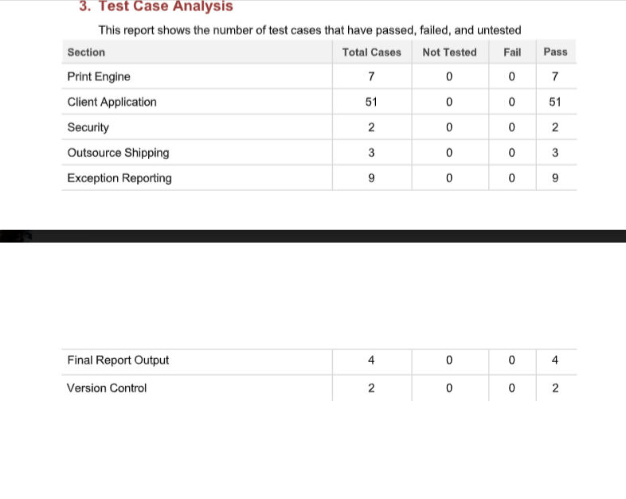

**9. RESULT**

**9.1 Performance Metrics**

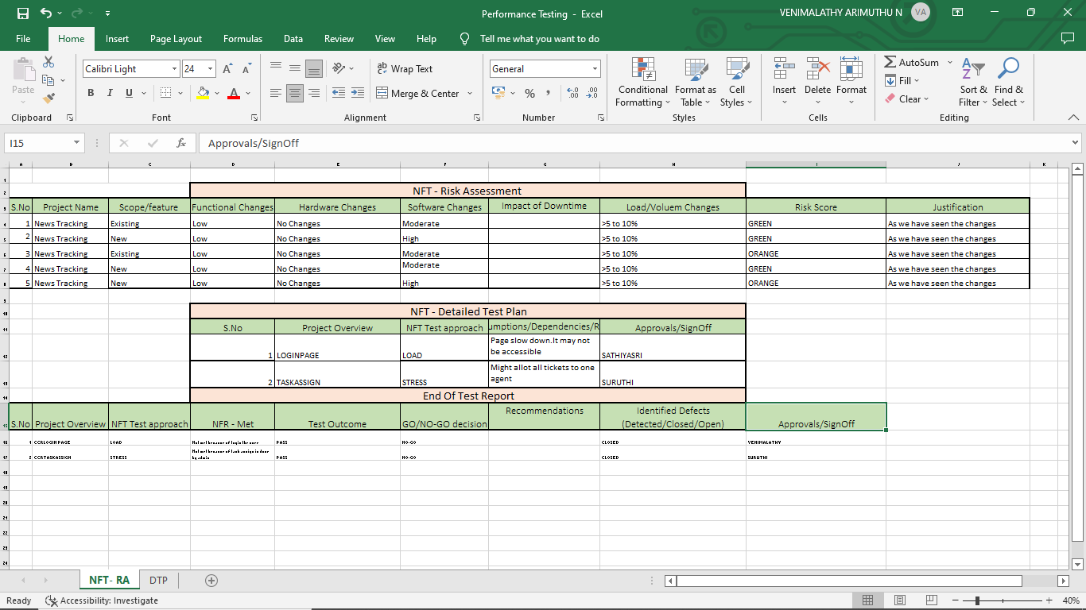

**10. ADVANTAGES & DISADVANTAGES**

**Advantages:**

➢ It provides higher accuracy through cross validation.

➢ High stability compare to Existing system.

➢ It is an user-friendly application.

➢ To explore and discover trending news and topics.

➢ Easily accessible and portable.

➢ Better user experience.

**Disadvantage:**

➢ Occurrence of Advertisement disturb the user.

➢ Sometimes the news gives brief information.

➢ It works only through internet.

➢ Device fault may affect the application.

➢ Fake news may mislead the readers.

**11. CONCLUSION**

Digital news brings about economic change, which in some cases obliterates journalists’ job prospects and professional security. Journalism speeds up, and journalists struggle to keep pace. Continually published updates on Twitter and online news streams force journalists onto a “hamster wheel” of news production, demanding frequent updates and preventing deep investigation and consideration of the topic at hand (Usher). While print journalism required 70 advertising dollars to sustain it, online journalism demands clicks to attract revenue, which shifts the orientation of journalism to “clickable,” consumable media. Scholars and commentators point out that journalism measured by web traffic privileges the production of aggregated news over original, well researched articles.

**12.FUTURE SCOPE**:

In the future we will further explore the design of adaptive interfaces, in order to be in a position to demonstrate a complete adaptive mobile news framework providing automatic personalization of news apps.

**GitHub & Project Demo Link**

**GitHub Link:**

<https://github.com/IBM-EPBL/IBM-Project-38335-1660378731>

**Project Demo Link:**

* <https://drive.google.com/file/d/1O9eR2WNIV4dSsmN1qBwB66uxObWF_R6A/view?usp=drivesdk>
* [**https://youtu.be/yERJN-Czcq0**](https://youtu.be/yERJN-Czcq0)